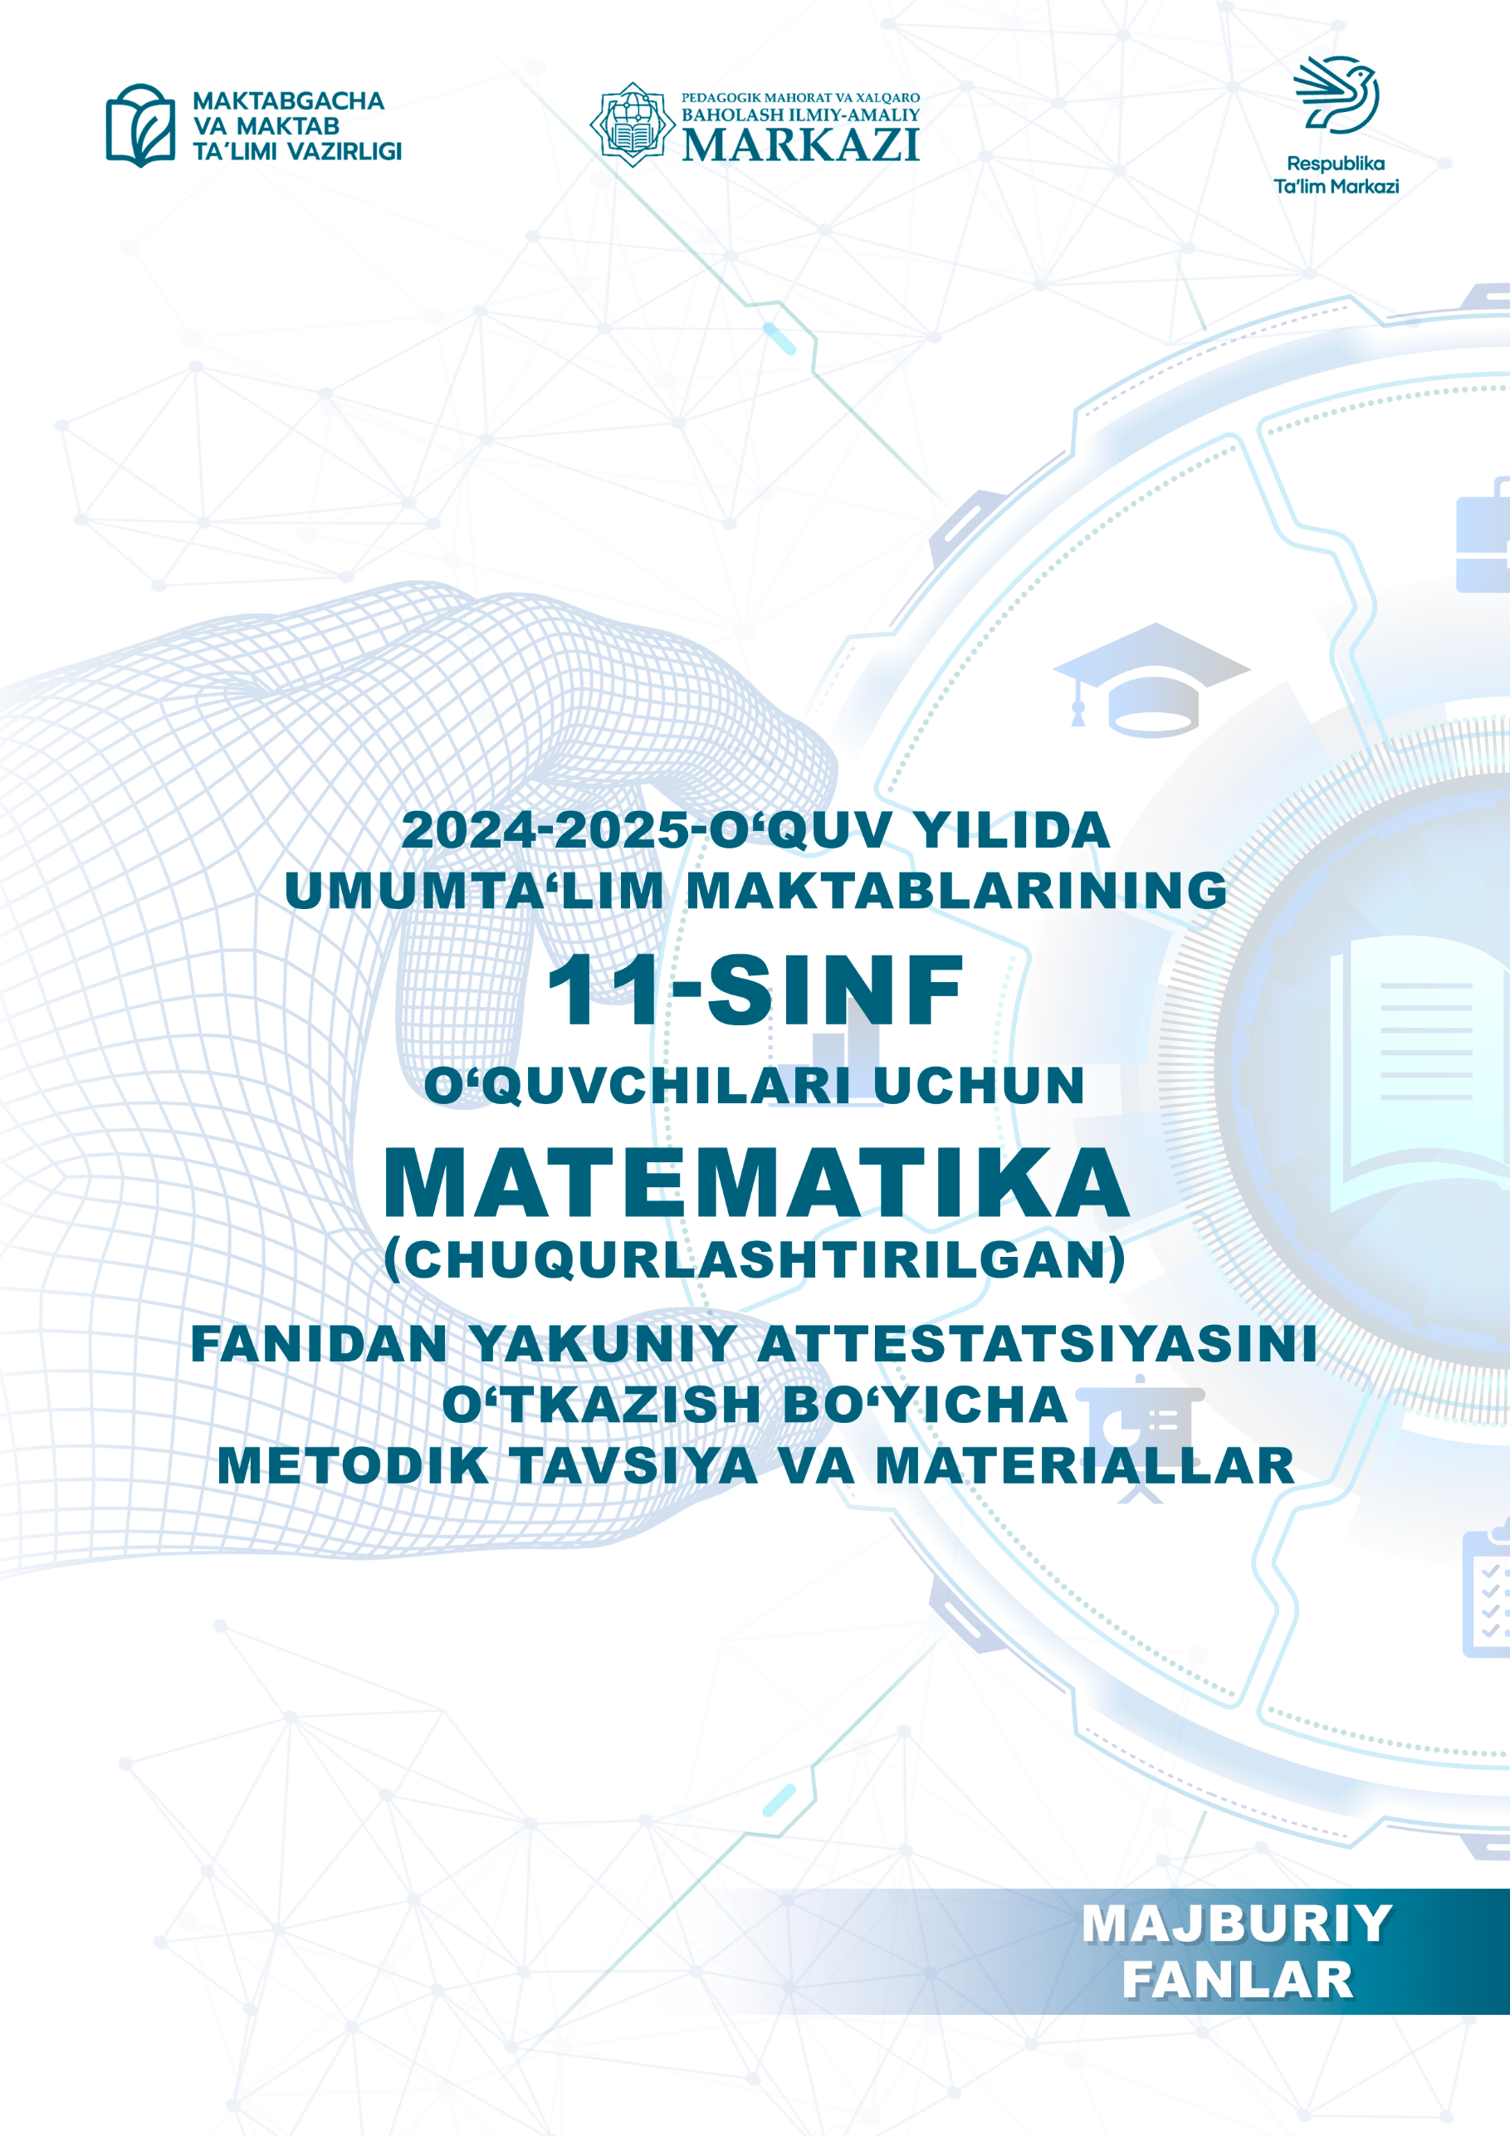

**Tuzuvchilar: S.F.Salayev, M.X.Komilov, Sh.T.Kojamuratova** Pedagogik mahorat vaxalqaro baholash ilmiy-amaliy markazi mutaxassislari.

**Taqrizchilar: M.A.Mirzaxmedov** Pedagogik mahorat va xalqaro baholash ilmiy-amaliy markazi eksperti.

**D.E. Shnol-** Taʼlim bo‘yicha xalqaro ekspert.

**OʻZBEKISTON RESPUBLIKASI MAKTABGACHA VA MAKTAB TAʼLIMI VAZIRINING 2025-yil 20-fevraldagi “2024/2025-oʻquv yilida umumiy oʻrta taʼlim muassasalarida oʻquvchilarning yakuniy davlat attestatsiyasini tashkil etish va oʻtkazish toʻgʻrisida”gi 65-son buyrug‘i**

O‘quvchilarning tanlov matematika fanidan olgan bilim, ko‘nikma va malakalarini aniqlash uchun 2024–2025-o‘quv yilida 11-sinflarda yakuniy imtihon yozma shaklda o‘tkaziladi.

**I. 11-sinflarda matematika fanidan yakuniy attestatsiya variantining tuzilishi.**

Imtihon ishining har bir varianti ikki qismdan iborat bo‘lib, shakli va murakkablik darajasi turlicha bo‘lgan 20 ta topshiriqni o‘z ichiga oladi (5-jadval).

**1-qism** 15 ta qisqa javobli topshiriqdan tashkil topgan. Bunda javob bitta son, birligi bilan yozilgan kattalik yoki moslashtirilgan jadval koʻrinishida berilishi kerak.

**2-qism** kengaytirilgan javobli 5 ta topshiriqni o‘z ichiga oladi, ularda masalaning yechimini asoslab, chizmalari bilan taqdim etish lozim.

Har bir imtihon variantining savol va topshiriqlari matematika fani bo‘yicha umumtaʻlim maktablarning Algebra va analiz asoslari, Ehtimollar nazariyasi va Statistika mazmun sohalarini qamrab olgan. Shuningdek, tavsiyada bilishga oid savollar, qo‘llashga va mulohazaga oid topshiriqlar bo‘yicha baholash mezonlari keltirilgan.

Har bir variantda o‘quvchiga 20 tadan (12 ta algebra, 8 ta geometriya) savol beriladi. Savollarning 5 tasi (3 ta algebra, 2 ta geometriya) bilishga, 13 tasi (8 ta algebra, 5 ta geometriya) qo‘llashga, 2 tasi (1 ta algebra, 1 ta geometriya) mulohazaga oid bo‘ladi. Variant topshiriqlarini bajarish uchun 240 daqiqa vaqt beriladi.

Oʻquvchilarning yozma ishlari algebra 100 ball va geometriya 100 ball asosida baholanadi:

0 – 29% – “qoniqarsiz”;

30–65% – “qoniqarli”;

66–85% – “yaxshi”;

86–100% – “a’lo”.

Javoblar varaqasini to‘ldirish shartlari:

moslikni aniqlashga doir topshiriqlarda har bir bo‘sh katakka faqat bitta harf (bosma harfda) yoki raqam ortiqcha belgilarsiz yozilishi kerak, aks holda 0 ball qo‘yiladi;

qisqa javobli topshiriqlarning javoblari faqat raqamlarda va topshiriqda so‘ralgan o‘lchov birliklarida (bosma harflarda) yozilishi kerak, aks holda 0 ball qo‘yiladi;

har bir katakka faqat bitta raqam yoziladi, agar javob manfiy son bo‘lsa, minus belgisi alohida katakka yoziladi, o‘nli kasr bo‘lsa vergul ham alohida katakka yoziladi, burchakning qiymati so‘ralgan topshiriqlarda burchak gradus o‘lchov birligida gradus belgisisiz yoziladi;

kengaytirilgan javobli topshiriqlar baholovchi fan ekspertlari tomonidan belgilangan mezonlar asosida tekshiriladi. Har bir topshiriq uchun batafsil baholash mezonlari berilgan bo‘lib, unda har bir ball (noldan maksimal ballgacha) qanday holatda qo‘yilishi aniq ko‘rsatiladi;

har bir topshiriq uchun belgilangan balldan yuqori ball qoʻyilishiga yoʻl qoʻyilmaydi.

1-jadval

*Sinov materiallarining qismlar boʻyicha taqsimoti*

|  |  |  |  |  |  |  |  |
| --- | --- | --- | --- | --- | --- | --- | --- |
| **Qism** | **Topshiriqlar soni** | **Algebra** | **Geometriya** | **Topshiriq shakli** | **Algebra bali** | **Geometriya bali** | **Qism ulushi %** |
| 1-qism | 15 | 9 | 6 | Qisqa javobli | 72 | 72 | 75 |
| 2-qism | 5 | 3 | 2 | Toʻliq yechimi keltirilgan | 28 | 28 | 25 |
| **Jami** | **20** | **12** | **8** |  | **100** | **100** | **100** |

2-jadval

*Mazmun sohalari boʻyicha topshiriqlarning taqsimoti*

|  |  |  |  |  |  |
| --- | --- | --- | --- | --- | --- |
| **Mazmun soha** | **Topshiriqlar soni** | **Topshiriqlarning foizi** | **Qisqa javobli bali** | **Toʻliq javobli bali** | **Jami ball** |
| Algebra va analiz asoslari | 10 | 50 | 56 | 28 | 84 |
| Ehtimollar nazariyasi va statistika | 2 | 10 | 16 |  | 16 |
| Geometriya | 8 | 40 | 72 | 28 | 100 |

3-jadval

*Baholanadigan koʻnikmalar taqsimoti*

|  |  |  |  |
| --- | --- | --- | --- |
| **Fan** | **Bilish** | **Qoʻllash** | **Mulohaza** |
| Algebra | 3 | 8 | 1 |
| Geometriya | 2 | 5 | 1 |
| **Jami** | **5** | **13** | **2** |

B-bilish, reproduktiv darajadagi topshiriqlarining mazmuni o‘quvchilar tomonidan o‘quv materiali qayta ishlanmasdan, ularning xotira qobiliyatini aniqlovchi, qonuniyatlar, xossalar, formula, tushuncha va atamalarning mohiyatini bilish, ***yodda saqlash va tanish, odatiy vaziyatlarda*** qo‘llashga qaratilgan.

Q-qo‘llash, produktiv o‘quv topshiriqlari – o‘quvchilardan o‘rganilgan mavzuga oid qonun va qonuniyatlar, xossalar va formulalarni qo‘llash, berilgan topshiriqlarga mos usullarni tanlash, tahlil qilish, taqqoslash, qiyoslash*,* ***bir nechta qonun va qonuniyatlarni*** bir vaqtda qo‘llab, umumlashtirish va xulosa yasashni talab qiladi.

M-mulohaza, intellektual darajadagi topshiriqlar o‘zlashtirilgan bilim, ko‘nikma va malakalarni ***notanish vaziyatlarda*** qo‘llash, tahlil qilish, sintezlash, qiyosiy taqqoslash, qonun va qonuniyatlarni qo‘llab, umumlashtirishni talab qiladi.

4-jadval

*Sinov materiallari ballarining taqsimoti*

|  |  |  |  |  |
| --- | --- | --- | --- | --- |
|  | **Qisqa javobli**  **bali/soni** | **Toʻliq yechimli bali/soni** | **Mulohaza toʻliq yechimli bali/soni** | **Jami** |
| Algebra | 8 ball / 9 ta | 9 ball / 2 ta | 10 ball / 1 ta | 100 |
| Geometriya | 12 ball / 6 ta | 13 ball / 1 ta | 15 ball / 1 ta | 100 |

5-jadval

*Topshiriqlarda baholanadigan koʻnikmalar*

|  |  |  |  |  |  |  |
| --- | --- | --- | --- | --- | --- | --- |
| **Topshiriq tartib raqami** | **Boʻlim nomi** | **Baholanadigan koʻnikmalar** | **Koʻnikma darajasi** | **Topshiriq shakli** | **Ball** | **Qism** |
| **Algebra** | | | | | |  |
| 1 | Funksiyalar (grafiklarni o‘qish) | Elementar funksiyalarning grafiklarini xossalari yordamida farqlay oladi | B | Qisqa javobli  Moslikni aniqlash | 8 | I |
| 2 | Ko‘rsatkichli tenglama va tengsizliklar | Ko‘rsatkichli tenglama va tengsizliklarni daraja xossalaridan foydalanib, yangi o‘zgaruvchi kiritib, ko‘rsatkichli funksiya xossalarini hisobga olgan holda yechimlarini topa oladi | Q | Qisqa javobli | 8 | I |
| 3 | Logarifmik tenglama va tengsizliklar | Logarifmik tenglama va tengsizliklarni logarifm xossalaridan foydalanib, ayniy almashtirishlar bajarib, logarifmik funksiya xossalarini hisobga olgan holda yechimlarini topa oladi | Q | Qisqa javobli | 8 | I |
| 4 | Trigonometrik tenglamalar | Trigonometrik tenglamalarning yechimini trigonometrik ayniyatlar va formulalar, trigonometrik funksiyalar xossalaridan foydalanib topa oladi | Q | Qisqa javobli | 8 | I |
| 5 | Trigonometrik tengsizliklar | Trigonometrik tengsizliklar yechimini topishda trigonometrik ayniyatlar va formulalar, trigonometrik funksiyalar xossalaridan foydalana oladi | Q | Toʻliq yechimli | 9 | II |
| 6 | Hosila yordamida yechiladigan masalalar | Hosilani hisoblash qoidalari, murakkab funksiya hosilasi, funksiya grafigiga o‘tkazilgan urinma va normal tenglamalaridan foydalanib, geometrik, fizik va iqtisodiy mazmundagi masalalarni yecha oladi | Q | Toʻliq yechimli | 9 | II |
| 7 | Boshlang‘ich funksiya | Berilgan funksiyalarning boshlang‘ich funksiyalarini topa oladi | B | Qisqa javobli  Moslikni aniqlash | 8 | I |
| 8 | Integral: integrallash usullari, aniq integral (integraldagi funksiyani soddalashtirish lozim bo‘lgan) | Aniq integralni asoslab hisoblashda integrallash usullari va qoidalarini qo‘llay oladi | Q | Qisqa javobli | 9 | I |
| 9 | Egri chiziqli trapetsiya. Jism hajmini topish | Egri chiziqli trapetsiya yuzini va jism hajmini topishda, yechimni asoslab berishda aniq integralni tadbiq qila oladi | M | Toʻliq yechimli | 10 | II |
| 10 | Ma’lumotlar tahlili | Turli ko‘rinishda berilgan statistik ma’lumotlarni tahlil qila oladi | B | Qisqa javobli | 8 | I |
| 11 | Kombinatorika masalalari | Kombinatorikaning formulalarini amaliy masalalar yechishda qo‘llay oladi | Q | Qisqa javobli | 8 | I |
| 12 | Ehtimollik | Tasodifiy hodisalar ehtimolligini turli usullarda hisoblay oladi | Q | Qisqa javobli | 8 | I |
| **Geometriya** | | | | | |  |
| 13 | Fazoda vektorlar | Fazoda vektorlar ustida amallar bajarishda vektorlar xossalarini qo‘llay oladi | B | Qisqa javobli | 12 | I |
| 14 | Fazoda to‘g‘ri chiziqlar | Fazoda to‘g‘ri chiziq va tekisliklarning o‘zaro joylashuviga oid masalalarni yecha oladi | B | Qisqa javobli | 12 | I |
| 15 | Prizmalar | Prizmalarning sirti, hajmini topish, turli kesimlarini hosil qilishda formulalarni qo‘llay oladi | Q | Qisqa javobli | 12 | I |
| 16 | Silindr | Silindrning sirti, hajmini topish, turli kesimlarini hosil qilishda formulalarni qo‘llay oladi | Q | Qisqa javobli | 12 | I |
| 17 | Piramidalar | Piramida va kesik piramida elementlari kattaliklarini bir-biri bilan bog‘lay oladi, sirti va hajmini topish formulalarini qo‘llay oladi | Q | Toʻliq yechimli | 13 | II |
| 18 | Konus | Konus va kesik konus elementlari kattaliklarini bir-biri bilan bog‘lay oladi, sirti va hajmini topish formulalarini qo‘llay oladi | Q | Qisqa javobli | 12 | I |
| 19 | Shar va sfera | Shar va sfera, ularning kesimlarini hosil qila oladi, sirti va hajmini aniqlay oladi | Q | Qisqa javobli | 12 | I |
| 20 | Geometrik jismlar kombinatsiyasi | Geometrik jismlarning kombinatsiyasiga oid amaliy masalalarning yechimini asoslab topa oladi | M | Toʻliq yechimli | 15 | II |

**Foydalanilgan adabiyotlar**

1. Algebra va analiz asoslari 10-sinf darslik. A.Zaitov (va boshq). Toshkent: Respublika ta’lim markazi, 2022.
2. Geometriya 10-sinf darslik. B.Xaydarov (va boshq). Toshkent: Respublika ta’lim markazi, 2022.
3. Matematika 11-sinf, I va II qism darslik. M.A.Mirzaahmedov, Sh.N.Ismoilov, A.Q.Amanov. Toshkent, 2018.

11 sinf yakuniy imtixon materiallari Algebra topshiriqlari

|  |  |  |  |  |  |  |
| --- | --- | --- | --- | --- | --- | --- |
| 1 | Funksiyalar (grafiklarni o‘qish) | Elementar funksiyalarning grafiklarini xossalari yordamida farqlay oladi | B | Qisqa javobli  Moslikni aniqlash | 8 | I |

1. Quyida keltirilgan grafiklarga mos funksiyani toping va to‘g‘ri javoblarni mos keltiring.

|  |  |  |
| --- | --- | --- |
| A. | B. | C. |

|  |  |  |  |  |
| --- | --- | --- | --- | --- |
| I. | II. | III. | IV. | V. |

|  |  |  |  |  |  |  |
| --- | --- | --- | --- | --- | --- | --- |
| Javob | A |  | B |  | C |  |

2. Quyida keltirilgan grafiklarga mos funksiyani toping va to‘g‘ri javoblarni mos keltiring.

|  |  |  |
| --- | --- | --- |
| A. | B. | C. |

|  |  |  |  |  |
| --- | --- | --- | --- | --- |
| I. | II. | III. | IV. | V. |

|  |  |  |  |  |  |  |
| --- | --- | --- | --- | --- | --- | --- |
| Javob | A |  | B |  | C |  |

3. Quyida keltirilgan grafiklarga mos funksiyani toping va to‘g‘ri javoblarni mos keltiring.

|  |  |  |
| --- | --- | --- |
| A. | B. | C. |

|  |  |  |  |  |
| --- | --- | --- | --- | --- |
| I. | II. | III. | IV. | V. |

|  |  |  |  |  |  |  |
| --- | --- | --- | --- | --- | --- | --- |
| Javob | A |  | B |  | C |  |

4. Quyida keltirilgan grafiklarga mos funksiyani toping va to‘g‘ri javoblarni mos keltiring.

|  |  |  |
| --- | --- | --- |
| A. | B. | C. |

|  |  |  |  |  |
| --- | --- | --- | --- | --- |
| I. | II. | III. | IV. | V. |

|  |  |  |  |  |  |  |
| --- | --- | --- | --- | --- | --- | --- |
| Javob | A |  | B |  | C |  |

5. Quyida keltirilgan grafiklarga mos funksiyani toping va to‘g‘ri javoblarni mos keltiring.

|  |  |  |
| --- | --- | --- |
| A. | B. | C. |

|  |  |  |  |  |
| --- | --- | --- | --- | --- |
| I. | II. | III. | IV. | V. |

|  |  |  |  |  |  |  |
| --- | --- | --- | --- | --- | --- | --- |
| Javob | A |  | B |  | C |  |

6. Quyida keltirilgan grafiklarga mos funksiyani toping va to‘g‘ri javoblarni mos keltiring.

|  |  |  |
| --- | --- | --- |
| A. | B. | C. |

|  |  |  |  |  |
| --- | --- | --- | --- | --- |
| I. | II. | III. | IV. | V. |

|  |  |  |  |  |  |  |
| --- | --- | --- | --- | --- | --- | --- |
| Javob | A |  | B |  | C |  |

7. Quyida keltirilgan grafiklarga mos funksiyani toping va to‘g‘ri javoblarni mos keltiring.

|  |  |  |
| --- | --- | --- |
| A. | B. | C. |

|  |  |  |  |  |
| --- | --- | --- | --- | --- |
| I. | II. | III. | IV. | V. |

|  |  |  |  |  |  |  |
| --- | --- | --- | --- | --- | --- | --- |
| Javob | A |  | B |  | C |  |

8. Quyida keltirilgan grafiklarga mos funksiyani toping va to‘g‘ri javoblarni mos keltiring.

|  |  |  |
| --- | --- | --- |
| A. | B. | C. |

|  |  |  |  |  |
| --- | --- | --- | --- | --- |
| I. | II. | III. | IV. | V. |

|  |  |  |  |  |  |  |
| --- | --- | --- | --- | --- | --- | --- |
| Javob | A |  | B |  | C |  |

9. Quyida keltirilgan grafiklarga mos funksiyani toping va to‘g‘ri javoblarni mos keltiring.

|  |  |  |
| --- | --- | --- |
| A. | B. | C. |

|  |  |  |  |  |
| --- | --- | --- | --- | --- |
| I. | II. | III. | IV. | V. |

|  |  |  |  |  |  |  |
| --- | --- | --- | --- | --- | --- | --- |
| Javob | A |  | B |  | C |  |

10. Quyida keltirilgan grafiklarga mos funksiyani toping va to‘g‘ri javoblarni mos keltiring.

|  |  |  |
| --- | --- | --- |
| A. | B. | C. |

|  |  |  |  |  |
| --- | --- | --- | --- | --- |
| I. $$y=\log_{\frac{1}{2}}{x}-2$$ | II. $$y=\log_{\frac{1}{2}}{(x-2)}$$ | III. $$y=\log_{\frac{1}{2}}{x}+2$$ | IV. $$y=\log_{\frac{1}{2}}{x}$$ | V. |

|  |  |  |  |  |  |  |
| --- | --- | --- | --- | --- | --- | --- |
| Javob | A |  | B |  | C |  |

|  |  |  |  |  |  |  |
| --- | --- | --- | --- | --- | --- | --- |
| 2 | Ko‘rsatkichli tenglama va tengsizliklar | Ko‘rsatkichli tenglama va tengsizliklarni daraja xossalaridan foydalanib, yangi o‘zgaruvchi kiritib, ko‘rsatkichli funksiya xossalarini hisobga olgan holda yechimlarini topa oladi | Q | Qisqa javobli  Har bir katakka faqat bitta raqam yoziladi, agar javob manfiy son bo‘lsa, minus belgisi alohida katakka yoziladi, o‘nli kasr bo‘lsa vergul ham alohida katakka yoziladi | 8 | I |

1. Tenglamani yeching.

|  |  |  |  |  |  |  |  |  |  |
| --- | --- | --- | --- | --- | --- | --- | --- | --- | --- |
| Javob |  |  |  |  |  |  |  |  |  |

2. Tenglamani yeching.

|  |  |  |  |  |  |  |  |  |  |
| --- | --- | --- | --- | --- | --- | --- | --- | --- | --- |
| Javob |  |  |  |  |  |  |  |  |  |

3. Tenglama ildizlari yig‘indisini toping.

|  |  |  |  |  |  |  |  |  |  |
| --- | --- | --- | --- | --- | --- | --- | --- | --- | --- |
| Javob |  |  |  |  |  |  |  |  |  |

4. Tenglama ildizlari yig‘indisini toping.

|  |  |  |  |  |  |  |  |  |  |
| --- | --- | --- | --- | --- | --- | --- | --- | --- | --- |
| Javob |  |  |  |  |  |  |  |  |  |

5. Tenglamani yeching.

|  |  |  |  |  |  |  |  |  |  |
| --- | --- | --- | --- | --- | --- | --- | --- | --- | --- |
| Javob |  |  |  |  |  |  |  |  |  |

6. Tengsizlikni qanoatlantiruvchi eng kichik butun sonni toping.

|  |  |  |  |  |  |  |  |  |  |
| --- | --- | --- | --- | --- | --- | --- | --- | --- | --- |
| Javob |  |  |  |  |  |  |  |  |  |

7. Tengsizlikni qanoatlantiruvchi eng katta butun sonni toping.

|  |  |  |  |  |  |  |  |  |  |
| --- | --- | --- | --- | --- | --- | --- | --- | --- | --- |
| Javob |  |  |  |  |  |  |  |  |  |

8. Tengsizlikni qanoatlantiruvchi eng kichik butun sonni toping.

|  |  |  |  |  |  |  |  |  |  |
| --- | --- | --- | --- | --- | --- | --- | --- | --- | --- |
| Javob |  |  |  |  |  |  |  |  |  |

9. Tengsizlikni qanoatlantiruvchi eng katta manfiy butun sonni toping.

|  |  |  |  |  |  |  |  |  |  |
| --- | --- | --- | --- | --- | --- | --- | --- | --- | --- |
| Javob |  |  |  |  |  |  |  |  |  |

10. Tengsizlikni qanoatlantiruvchi eng kichik musbat butun sonni toping.

$$9^{x}-10∙3^{x}+9>0$$

|  |  |  |  |  |  |  |  |  |  |
| --- | --- | --- | --- | --- | --- | --- | --- | --- | --- |
| Javob |  |  |  |  |  |  |  |  |  |

|  |  |  |  |  |  |  |
| --- | --- | --- | --- | --- | --- | --- |
| 3 | Logarifmik tenglama va tengsizliklar | Logarifmik tenglama va tengsizliklarni logarifm xossalaridan foydalanib, ayniy almashtirishlar bajarib, logarifmik funksiya xossalarini hisobga olgan holda yechimlarini topa oladi | Q | Qisqa javobli | 8 | I |

1. Tenglamani yeching:

|  |  |  |  |  |  |  |  |  |  |
| --- | --- | --- | --- | --- | --- | --- | --- | --- | --- |
| Javob |  |  |  |  |  |  |  |  |  |

2. Tenglama ildizlari ko‘paytmasini toping:

|  |  |  |  |  |  |  |  |  |  |
| --- | --- | --- | --- | --- | --- | --- | --- | --- | --- |
| Javob |  |  |  |  |  |  |  |  |  |

3. Tenglama ildizlari yig‘indisini toping:

|  |  |  |  |  |  |  |  |  |  |
| --- | --- | --- | --- | --- | --- | --- | --- | --- | --- |
| Javob |  |  |  |  |  |  |  |  |  |

4. Tenglamani yeching:

|  |  |  |  |  |  |  |  |  |  |
| --- | --- | --- | --- | --- | --- | --- | --- | --- | --- |
| Javob |  |  |  |  |  |  |  |  |  |

5. Tenglamani yeching:

|  |  |  |  |  |  |  |  |  |  |
| --- | --- | --- | --- | --- | --- | --- | --- | --- | --- |
| Javob |  |  |  |  |  |  |  |  |  |

6. Tengsizlikni qanoatlantiruvchi butun sonlar yig‘indisini toping:

|  |  |  |  |  |  |  |  |  |  |
| --- | --- | --- | --- | --- | --- | --- | --- | --- | --- |
| Javob |  |  |  |  |  |  |  |  |  |

7. Tengsizlikni qanoatlantiruvchi barcha musbat butun sonlar yig‘indisini toping:

|  |  |  |  |  |  |  |  |  |  |
| --- | --- | --- | --- | --- | --- | --- | --- | --- | --- |
| Javob |  |  |  |  |  |  |  |  |  |

8. Tengsizlikni qanoatlantiruvchi barcha butun sonlar yig‘indisini toping:

|  |  |  |  |  |  |  |  |  |  |
| --- | --- | --- | --- | --- | --- | --- | --- | --- | --- |
| Javob |  |  |  |  |  |  |  |  |  |

9. Tengsizlikni nechta natural son qanoatlantirishini aniqlang:

|  |  |  |  |  |  |  |  |  |  |
| --- | --- | --- | --- | --- | --- | --- | --- | --- | --- |
| Javob |  |  |  |  |  |  |  |  |  |

10. Tengsizlikni qanoatlantiruvchi 30 dan kichik natural sonlar nechta?

$$\log_{3}^{2}x-4\log_{3}{x}+3>0$$

|  |  |  |  |  |  |  |  |  |  |
| --- | --- | --- | --- | --- | --- | --- | --- | --- | --- |
| Javob |  |  |  |  |  |  |  |  |  |

|  |  |  |  |  |  |  |
| --- | --- | --- | --- | --- | --- | --- |
| 4 | Trigonometrik tenglamalar | Trigonometrik tenglamalarning yechimini trigonometrik ayniyatlar va formulalar, trigonometrik funksiyalar xossalaridan foydalanib topa oladi | Q | Qisqa javobli | 8 | I |

1. Tenglamani kesmadagi yechimlari yig‘indisi necha gradusga teng?

|  |  |  |  |  |  |  |  |  |  |
| --- | --- | --- | --- | --- | --- | --- | --- | --- | --- |
| Javob |  |  |  |  |  |  |  |  |  |

2. Tenglamani kesmadagi yechimlari yig‘indisi necha gradusga teng?

|  |  |  |  |  |  |  |  |  |  |
| --- | --- | --- | --- | --- | --- | --- | --- | --- | --- |
| Javob |  |  |  |  |  |  |  |  |  |

3. Tenglamani kesmadagi yechimlari yig‘indisi necha gradusga teng?

|  |  |  |  |  |  |  |  |  |  |
| --- | --- | --- | --- | --- | --- | --- | --- | --- | --- |
| Javob |  |  |  |  |  |  |  |  |  |

4. Tenglamani kesmadagi yechimlari yig‘indisi necha gradusga teng?

|  |  |  |  |  |  |  |  |  |  |
| --- | --- | --- | --- | --- | --- | --- | --- | --- | --- |
| Javob |  |  |  |  |  |  |  |  |  |

5. Tenglamani kesmadagi yechimlari yig‘indisi necha gradusga teng?

|  |  |  |  |  |  |  |  |  |  |
| --- | --- | --- | --- | --- | --- | --- | --- | --- | --- |
| Javob |  |  |  |  |  |  |  |  |  |

6. Tenglamani kesmadagi yechimlari yig‘indisi necha gradusga teng?

|  |  |  |  |  |  |  |  |  |  |
| --- | --- | --- | --- | --- | --- | --- | --- | --- | --- |
| Javob |  |  |  |  |  |  |  |  |  |

7. Tenglamani kesmadagi yechimlari yig‘indisi necha gradusga teng?

|  |  |  |  |  |  |  |  |  |  |
| --- | --- | --- | --- | --- | --- | --- | --- | --- | --- |
| Javob |  |  |  |  |  |  |  |  |  |

8. Tenglamani kesmadagi yechimlari yig‘indisi necha gradusga teng?

|  |  |  |  |  |  |  |  |  |  |
| --- | --- | --- | --- | --- | --- | --- | --- | --- | --- |
| Javob |  |  |  |  |  |  |  |  |  |

9. Tenglamani kesmadagi yechimlari yig‘indisi necha gradusga teng?

|  |  |  |  |  |  |  |  |  |  |
| --- | --- | --- | --- | --- | --- | --- | --- | --- | --- |
| Javob |  |  |  |  |  |  |  |  |  |

10. Tenglamani $\left[0;\frac{π}{2}\right]$ kesmadagi yechimlari yig‘indisi necha gradusga teng?

$$\sin\left(3x-\frac{π}{4}\right)=-\frac{1}{2}$$

|  |  |  |  |  |  |  |  |  |  |
| --- | --- | --- | --- | --- | --- | --- | --- | --- | --- |
| Javob |  |  |  |  |  |  |  |  |  |

|  |  |  |  |  |  |  |
| --- | --- | --- | --- | --- | --- | --- |
| 5 | Trigonometrik tengsizliklar | Trigonometrik tengsizliklar yechimini topishda trigonometrik ayniyatlar va formulalar, trigonometrik funksiyalar xossalaridan foydalana oladi | Q | Toʻliq yechimli | 9 | II |

1. Tengsizlikni yeching:

Yechish:

Javob: _________________________________

2. Tengsizlikni yeching:

Yechish:

Javob: _________________________________

3. Tengsizlikni yeching:

Yechish:

Javob: _________________________________

4. Tengsizlikni yeching:

Yechish:

Javob: _________________________________

5. Tengsizlikni yeching:

Yechish:

Javob: _________________________________

6. Tengsizlikni yeching:

Yechish:

Javob: _________________________________

7. Tengsizlikni yeching:

Yechish:

Javob: _________________________________

8. Tengsizlikni yeching:

Yechish:

Javob: _________________________________

9. Tengsizlikni yeching:

Yechish:

Javob: _________________________________

10. Tengsizlikni yeching: ${ctg}^{2}2x-2\operatorname{ctg}{2x}+1≤0$

Yechish:

Javob: _________________________________

|  |  |  |  |  |  |  |
| --- | --- | --- | --- | --- | --- | --- |
| 6 | Hosila yordamida yechiladigan masalalar | Hosilani hisoblash qoidalari, murakkab funksiya hosilasi, funksiya grafigiga o‘tkazilgan urinma va normal tenglamalaridan foydalanib, geometrik, fizik va iqtisodiy mazmundagi masalalarni yecha oladi | Q | Toʻliq yechimli | 9 | II |

1. funksiya grafigiga $x_{0}=4$ abssissali nuqtada o‘tkazilgan urinma tenglamasini tuzing va urinma bilan $Ox$ o‘qining musbat yo‘nalishi tashkil qilgan burchakning kosinusini toping.

Yechish:

Javob: _________________________________

2. funksiya uchun quyidagilarni toping:

a) statsionar nuqtalarni;

b) o‘sish va kamayish oraliqlarini;

c) lokal maksimum va lokal minimumlarini.

Yechish:

Javob: _________________________________

3. funksiya uchun quyidagilarni toping:

a) statsionar nuqtalarni;

b) o‘sish va kamayish oraliqlarini;

c) lokal maksimum va lokal minimumlarini.

Yechish:

Javob: _________________________________

4. Moddiy nuqta $s\left(t\right)=-\frac{t^{4}}{12}+t^{3}$ qonuniyat bilan harakatlanmoqda ( $s(t)$ metrda, $t$ vaqt esa sekundda o‘lchanadi). Quyidagilarni toping:

a) eng katta tezlanishga erishiladigan $t_{0}$ vaqtni;

b) $t_{0}$ vaqtdagi oniy tezlikni;

c) $t_{0}$ vaqt ichida bosib o‘tilgan yo‘lni.

Yechish:

Javob: _________________________________

5. Moddiy nuqta $s\left(t\right)=\frac{t^{3}}{3}-6t^{2}+4t+150$ qonuniyat bilan harakatlanmoqda ( $s(t)$ metrda, $t$ vaqt esa sekundda o‘lchanadi). Quyidagilarni toping:

a) eng kichik tezlikka erishiladigan $t_{0}$ vaqtni;

b) $t_{0}$ vaqtdagi tezlanishni;

c) $t_{0}$ vaqt ichida bosib o‘tilgan yo‘lni.

Yechish:

Javob: _________________________________

6. Tomoni 16 dm bo‘lgan kvadrat shaklidagi kartondan usti ochiq quti tayyorlandi. Bunda kartonning uchlaridan bir xil kvadratchalar kesib olindi. Qutining hajmi eng katta bo‘lishi uchun uning asosi necha santimetr bo‘lishi kerak?

Yechish:

Javob: _________________________________

7. Tomoni 24 dm bo‘lgan kvadrat shaklidagi kartondan usti ochiq quti tayyorlandi. Bunda kartonning uchlaridan bir xil kvadratchalar kesib olindi. Qutining hajmi eng katta bo‘lishi uchun uning asosi necha santimetr bo‘lishi kerak?

Yechish:

Javob: _________________________________

8. Ikki moddiy nuqta $s_{1}\left(t\right)=3t^{3}-4t^{2}+2t-1$ (m) va $s_{2}\left(t\right)=3t^{3}-2t^{2}-5t+3$ (m) qonuniyatlar bo‘yicha harakatlanayapti. Bu ikki nuqtaning tezliklari teng bo‘lgan paytda birinchi nuqtaning tezlanishini toping.

Yechish:

Javob: _________________________________

9. Havo shariga minut oralig‘ida (m3) hajmda havo purkalmoqda. Quyidagilarni toping:

a) boshlang‘ich vaqtdagi havo hajmini;

b) minutdagi havo hajmini;

c) minutdagi havo purkash tezligini.

Yechish:

Javob: _________________________________

10. Havo shariga minut oralig‘ida (m3) hajmda havo purkalmoqda. Quyidagilarni toping:

a) boshlang‘ich vaqtdagi havo hajmini;

b) $t=8$ minutdagi havo hajmini;

c) $t=5$ minutdagi havo purkash tezligini.

Yechish:

Javob: _________________________________

|  |  |  |  |  |  |  |
| --- | --- | --- | --- | --- | --- | --- |
| 7 | Boshlang‘ich funksiya | Berilgan funksiyalarning boshlang‘ich funksiyalarini topa oladi | B | Qisqa javobli  Moslikni aniqlash | 8 | I |

1. Berilgan funksiya larning boshlang‘ich funksiya larini toping va bir-biriga mos keltiring.

|  |  |
| --- | --- |
| I. | A. |
| B. |
| II. | C. |
| D. |
| III. | E. |
| F. |

|  |  |  |  |  |  |  |
| --- | --- | --- | --- | --- | --- | --- |
| Javob | I |  | II |  | III |  |

2. Berilgan funksiya larning boshlang‘ich funksiya larini toping va bir-biriga mos keltiring.

|  |  |
| --- | --- |
| I. | A. |
| B. |
| II. | C. |
| D. |
| III. | E. |
| F. |

|  |  |  |  |  |  |  |
| --- | --- | --- | --- | --- | --- | --- |
| Javob | I |  | II |  | III |  |

3. Berilgan funksiya larning boshlang‘ich funksiya larini toping va bir-biriga mos keltiring.

|  |  |
| --- | --- |
| I. | A. |
| B. |
| II. | C. |
| D. |
| III. | E. |
| F. |

|  |  |  |  |  |  |  |
| --- | --- | --- | --- | --- | --- | --- |
| Javob | I |  | II |  | III |  |

4. Berilgan funksiya larning boshlang‘ich funksiya larini toping va bir-biriga mos keltiring.

|  |  |
| --- | --- |
| I. | A. |
| B. |
| II. | C. |
| D. |
| III. | E. |
| F. |

|  |  |  |  |  |  |  |
| --- | --- | --- | --- | --- | --- | --- |
| Javob | I |  | II |  | III |  |

5. Berilgan funksiya larning boshlang‘ich funksiya larini toping va bir-biriga mos keltiring.

|  |  |
| --- | --- |
| I. | A. |
| B. |
| II. | C. |
| D. |
| III. | E. |
| F. |

|  |  |  |  |  |  |  |
| --- | --- | --- | --- | --- | --- | --- |
| Javob | I |  | II |  | III |  |

6. Berilgan funksiya larning boshlang‘ich funksiya larini toping va bir-biriga mos keltiring.

|  |  |
| --- | --- |
| I. | A. |
| B. |
| II. | C. |
| D. |
| III. | E. |
| F. |

|  |  |  |  |  |  |  |
| --- | --- | --- | --- | --- | --- | --- |
| Javob | I |  | II |  | III |  |

7. Berilgan funksiya larning boshlang‘ich funksiya larini toping va bir-biriga mos keltiring.

|  |  |
| --- | --- |
| I. | A. |
| B. |
| II. | C. |
| D. |
| III. | E. |
| F. |

|  |  |  |  |  |  |  |
| --- | --- | --- | --- | --- | --- | --- |
| Javob | I |  | II |  | III |  |

8. Berilgan funksiya larning boshlang‘ich funksiya larini toping va bir-biriga mos keltiring.

|  |  |
| --- | --- |
| I. | A. |
| B. |
| II. | C. |
| D. |
| III. | E. |
| F. |

|  |  |  |  |  |  |  |
| --- | --- | --- | --- | --- | --- | --- |
| Javob | I |  | II |  | III |  |

9. Berilgan funksiya larning boshlang‘ich funksiya larini toping va bir-biriga mos keltiring.

|  |  |
| --- | --- |
| I. | A. |
| B. |
| II. | C. |
| D. |
| III. | E. |
| F. |

|  |  |  |  |  |  |  |
| --- | --- | --- | --- | --- | --- | --- |
| Javob | I |  | II |  | III |  |

10. Berilgan funksiya $f(x)$ larning boshlang‘ich funksiya $F(x)$ larini toping va bir-biriga mos keltiring.

|  |  |
| --- | --- |
| I. $f\left(x\right)=e^{-2x}$ | A. $F\left(x\right)=-arctgx+C$ |
| B. $F\left(x\right)=-\frac{1}{2}e^{-2x}+C$ |
| II. $f\left(x\right)=\frac{1}{1+x^{2}}$ | C. $F\left(x\right)=3\sin\left(\frac{x}{3}\right)+C$ |
| D. $F\left(x\right)=-2e^{-2x}+C$ |
| III. $f\left(x\right)=\cos\left(\frac{x}{3}\right)$ | E. $F\left(x\right)=-\frac{1}{3}\sin\left(\frac{x}{3}\right)+C$ |
| F. |

|  |  |  |  |  |  |  |
| --- | --- | --- | --- | --- | --- | --- |
| Javob | I |  | II |  | III |  |

|  |  |  |  |  |  |  |
| --- | --- | --- | --- | --- | --- | --- |
| 8 | Integral: integrallash usullari, aniq integral (integraldagi funksiyani soddalashtirish lozim bo‘lgan) | Aniq integralni asoslab hisoblashda integrallash usullari va qoidalarini qo‘llay oladi | Q | Qisqa javobli | 9 | I |

1. Aniq integralni hisoblang ( deb oling):

|  |  |  |  |  |  |  |  |  |  |
| --- | --- | --- | --- | --- | --- | --- | --- | --- | --- |
| Javob |  |  |  |  |  |  |  |  |  |

2. Aniq integralni hisoblang:

|  |  |  |  |  |  |  |  |  |  |
| --- | --- | --- | --- | --- | --- | --- | --- | --- | --- |
| Javob |  |  |  |  |  |  |  |  |  |

3. Aniq integralni hisoblang ( deb oling):

|  |  |  |  |  |  |  |  |  |  |
| --- | --- | --- | --- | --- | --- | --- | --- | --- | --- |
| Javob |  |  |  |  |  |  |  |  |  |

4. Aniq integralni hisoblang ( deb oling):

|  |  |  |  |  |  |  |  |  |  |
| --- | --- | --- | --- | --- | --- | --- | --- | --- | --- |
| Javob |  |  |  |  |  |  |  |  |  |

5. Aniq integralni hisoblang:

|  |  |  |  |  |  |  |  |  |  |
| --- | --- | --- | --- | --- | --- | --- | --- | --- | --- |
| Javob |  |  |  |  |  |  |  |  |  |

6. Aniq integralni hisoblang ( deb oling):

|  |  |  |  |  |  |  |  |  |  |
| --- | --- | --- | --- | --- | --- | --- | --- | --- | --- |
| Javob |  |  |  |  |  |  |  |  |  |

7. Aniq integralni hisoblang:

|  |  |  |  |  |  |  |  |  |  |
| --- | --- | --- | --- | --- | --- | --- | --- | --- | --- |
| Javob |  |  |  |  |  |  |  |  |  |

8. Aniq untegralni hisoblang ( deb oling):

|  |  |  |  |  |  |  |  |  |  |
| --- | --- | --- | --- | --- | --- | --- | --- | --- | --- |
| Javob |  |  |  |  |  |  |  |  |  |

9. Aniq integralni hisoblang:

|  |  |  |  |  |  |  |  |  |  |
| --- | --- | --- | --- | --- | --- | --- | --- | --- | --- |
| Javob |  |  |  |  |  |  |  |  |  |

10. Aniq integralni hisoblang ( $\ln{2}=0,69$ va $\ln{3}=1,09$ deb oling):

$$\int_{5}^{6}{\frac{dx}{x^{2}-7x+12}}$$

|  |  |  |  |  |  |  |  |  |  |
| --- | --- | --- | --- | --- | --- | --- | --- | --- | --- |
| Javob |  |  |  |  |  |  |  |  |  |

|  |  |  |  |  |  |  |
| --- | --- | --- | --- | --- | --- | --- |
| 9 | Egri chiziqli trapetsiya. Jism hajmini topish | Egri chiziqli trapetsiya yuzini va jism hajmini topishda, yechimni asoslab berishda aniq integralni tadbiq qila oladi | M | Toʻliq yechimli | 10 | II |

1. Rasmdagi bo‘yalgan soha yuzini toping.

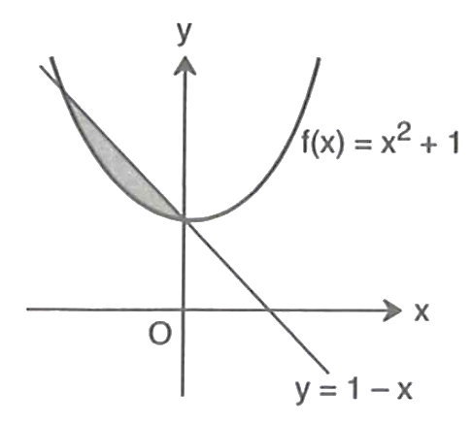

Yechish:

Javob: _________________________________

2. Rasmdagi bo‘yalgan soha yuzini toping.

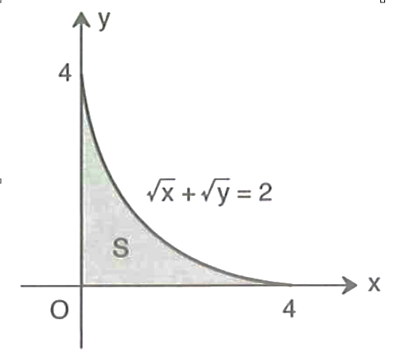

Yechish:

Javob: _________________________________

3. Rasmdagi bo‘yalgan soha yuzini toping.

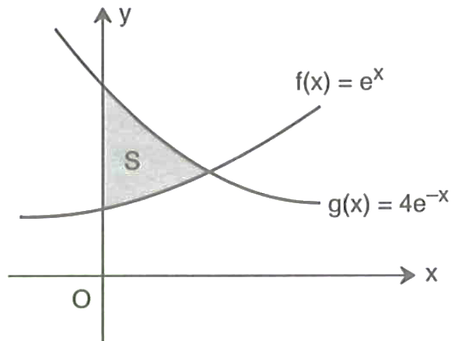

Yechish:

Javob: _________________________________

4. Rasmdagi bo‘yalgan soha yuzini toping.

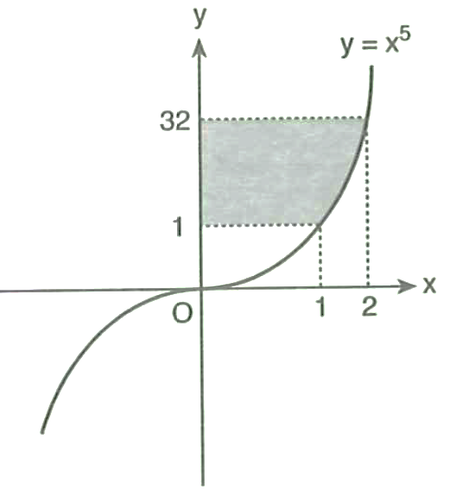

Yechish:

Javob: _________________________________

5. Rasmdagi bo‘yalgan soha yuzini toping.

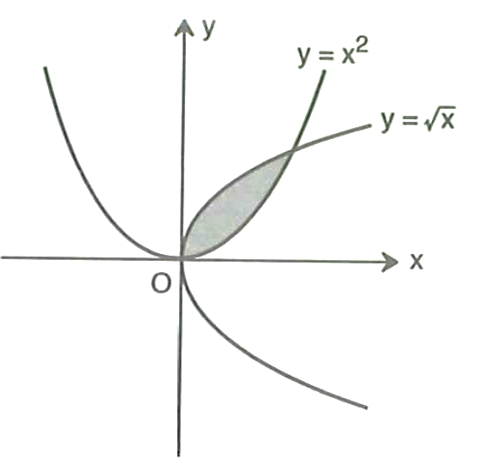

Yechish:

Javob: _________________________________

6. Rasmda bo‘yalgan sohaning o‘qi atrofida aylanishidan hosil bo‘ladigan jism hajmini toping.

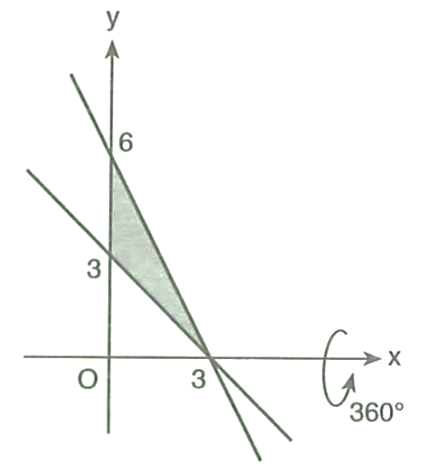

Yechish:

Javob: _________________________________

7. Rasmda bo‘yalgan sohaning o‘qi atrofida aylanishidan hosil bo‘ladigan jism hajmini toping.

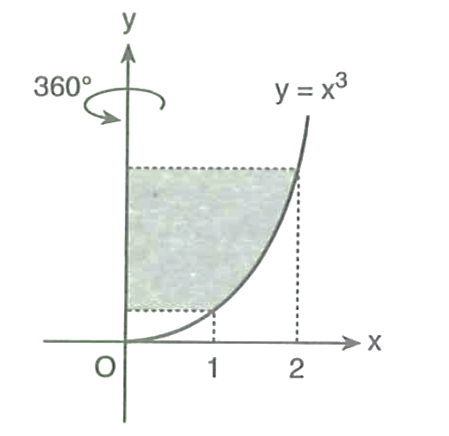

Yechish:

Javob: _________________________________

8. Rasmda bo‘yalgan sohaning o‘qi atrofida aylanishidan hosil bo‘ladigan jism hajmini toping.

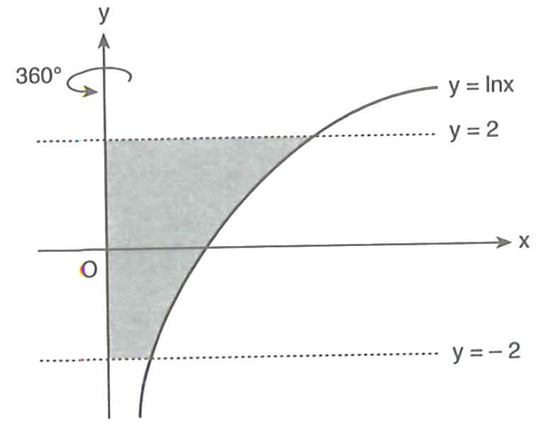

Yechish:

Javob: _________________________________

9. Rasmda bo‘yalgan sohaning o‘qi atrofida aylanishidan hosil bo‘ladigan jism hajmini toping.

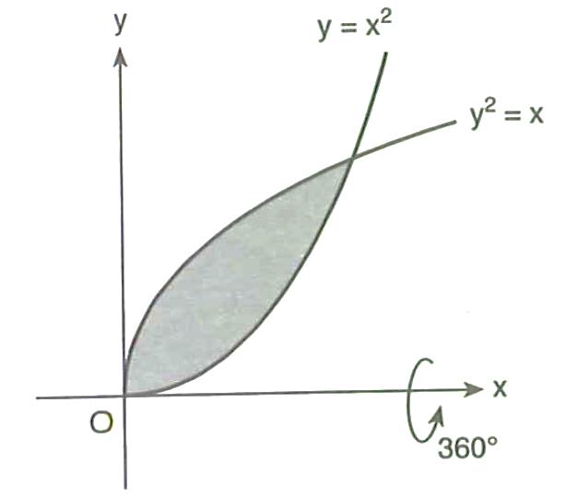

Yechish:

Javob: _________________________________

10. Rasmda bo‘yalgan sohaning $Oy$ o‘qi atrofida aylanishidan hosil bo‘ladigan jism hajmini toping.

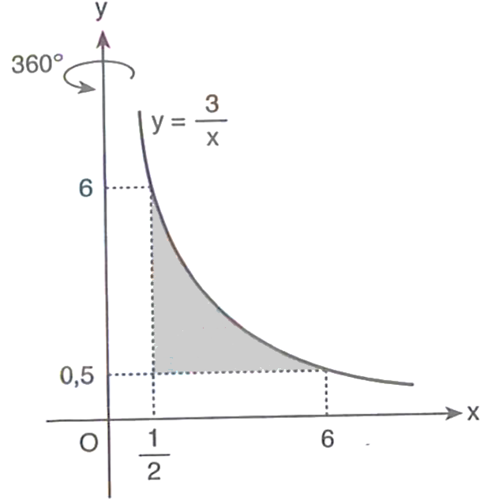

Yechish:

Javob: _________________________________

|  |  |  |  |  |  |  |
| --- | --- | --- | --- | --- | --- | --- |
| 10 | Ma’lumotlar tahlili | Turli ko‘rinishda berilgan statistik ma’lumotlarni tahlil qila oladi | B | Qisqa javobli | 8 | I |

1. **Smartfon batareya testi.** Bir texnologiya kompaniyasi sinov maqsadida 12 ta smartfonning batareya foizlarini (to‘liq zaryadlangan holda foydalanilgandan keyin qolgan foiz) aniqladi: 92, 85, 78, 80, 90, 88, 83, 75, 95, 81, 87, 89. Ushbu ro‘yhatning o‘rta qiymatini hisoblang.

|  |  |  |  |  |  |  |  |  |  |
| --- | --- | --- | --- | --- | --- | --- | --- | --- | --- |
| Javob |  |  |  |  |  |  |  |  |  |

2. **Buyurtmalar yetkazib berish vaqti.** Bir onlayn savdo platformasi buyurtmalarini yetkazib berish vaqtlarini (soatlarda) kuzatdi. Quyidagi taqsimot jadvali tuzilgan:

|  |  |  |  |  |  |
| --- | --- | --- | --- | --- | --- |
| Yetkazib berish vaqti (soat) | 1 | 2 | 3 | 4 | 5 |
| Ehtimollik | $$\frac{1}{10}$$ | $$\frac{3}{10}$$ | $$\frac{4}{10}$$ | $$\frac{3}{20}$$ | $$\frac{1}{20}$$ |

Ushbu ma’lumotlarga asoslanib, buyurtmaning matematik kutilmasini aniqlang.

|  |  |  |  |  |  |  |  |  |  |
| --- | --- | --- | --- | --- | --- | --- | --- | --- | --- |
| Javob |  |  |  |  |  |  |  |  |  |

3. **Mobil ilova foydalanuvchi baholari.** Bir mobil ilova uchun foydalanuvchilar tomonidan berilgan baholar quyidagicha:

$4, 5, 3, 4, 2, 5, 4, 3, 4, 5, 4$.

Ushbu baholarning modasi va medianasining yig‘indisini toping.

|  |  |  |  |  |  |  |  |  |  |
| --- | --- | --- | --- | --- | --- | --- | --- | --- | --- |
| Javob |  |  |  |  |  |  |  |  |  |

4. **Onlayn kurs baholash.** Bir onlayn kurs bo‘yicha ishtirokchilarning baholari:

$$8, 9, 7, 8, 6, 10, 8, 9.$$

Ushbu ro‘yhatning modasi va medianasi ko‘paytmasini toping.

|  |  |  |  |  |  |  |  |  |  |
| --- | --- | --- | --- | --- | --- | --- | --- | --- | --- |
| Javob |  |  |  |  |  |  |  |  |  |

5. **Smartfon ekran o‘lchamlari.** Yangi chiqayotgan smartfonlar ekran o‘lchamlari (dyuymda) bo‘yicha taqsimot jadvali:

|  |  |  |  |  |
| --- | --- | --- | --- | --- |
| $X$ (dyuym) | $$5,5$$ | $$6$$ | $$6,5$$ | $$7$$ |
| $M$ (soni) | $$4$$ | $$6$$ | $$3$$ | $$2$$ |

Ushbu ma’lumotlarga asoslanib, ekran o‘lchamining o‘rtacha qiymatini toping.

|  |  |  |  |  |  |  |  |  |  |
| --- | --- | --- | --- | --- | --- | --- | --- | --- | --- |
| Javob |  |  |  |  |  |  |  |  |  |

6. **Yetkazib berish vaqtlarining tahlili.** Bir logistika kompaniyasi 100 km masofaga yetkazib berish uchun foydalanilgan transport vositalarining ishlash vaqtlarini (soatlarda) qayd etdi:

$$1,2; 1,5; 1,3; 1,7; 1,4; 1,3.$$

Ushbu vaqtlarning o‘rta arifmetigi va medianasini hisoblab, ularning yig‘indisini toping.

|  |  |  |  |  |  |  |  |  |  |
| --- | --- | --- | --- | --- | --- | --- | --- | --- | --- |
| Javob |  |  |  |  |  |  |  |  |  |

7. **Yugurish natijalari.** Sportchi 100 m masofaga yugurish bo‘yicha quyidagi natijalarni qayd etdi (sekundlarda):

$$10,2; 10; 10,1; 10,3; 10,1; 10; 10,2; 10,4; 10; 10,3.$$

Ushbu sonlar qatorining medianasi va modasining o‘rta arifmetigini toping.

|  |  |  |  |  |  |  |  |  |  |
| --- | --- | --- | --- | --- | --- | --- | --- | --- | --- |
| Javob |  |  |  |  |  |  |  |  |  |

8. **Ijtimoiy tarmoqlarda faollik.** Bir tadqiqotda ijtimoiy tarmoqlarda kunlik faoliyat vaqti (soatlarda) kuzatilgan. Taqsimot jadvali:

|  |  |  |  |  |  |
| --- | --- | --- | --- | --- | --- |
| $X$ (soat) | 1 | 2 | 3 | 4 | 5 |
| $M$ (kunlar soni) | 5 | 12 | 18 | 10 | 5 |

Ushbu ma’lumotlarga asoslanib, kunlik faoliyat vaqtining modasi va medianasining ko‘paytmasini toping.

|  |  |  |  |  |  |  |  |  |  |
| --- | --- | --- | --- | --- | --- | --- | --- | --- | --- |
| Javob |  |  |  |  |  |  |  |  |  |

9. **Restoran mijozlari baholari.** Bir restoran mijozlari tomonidan berilgan baholar:

$$3, 4, 4, 5, 2, 5, 4, 3, 4, 5, 3, 4.$$

Ushbu tanlanmaning modasi va o‘zgarish kengligi yig‘indisini hisoblang.

|  |  |  |  |  |  |  |  |  |  |
| --- | --- | --- | --- | --- | --- | --- | --- | --- | --- |
| Javob |  |  |  |  |  |  |  |  |  |

10. **Xodimlar ish faoliyati baholari.** Bir kompaniyada xodimlarning ish faoliyati ko‘rsatkichlari (ballarda) quyidagi jadvalda ifodalangan:.

|  |  |  |  |
| --- | --- | --- | --- |
| $X$ (ball) | 60 | 70 | 80 |
| $M$ (soni) | 6 | 15 | 9 |

Ushbu ma’lumotlarga asoslanib, xodimlarning o‘rtacha bahosini hisoblang.

|  |  |  |  |  |  |  |  |  |  |
| --- | --- | --- | --- | --- | --- | --- | --- | --- | --- |
| Javob |  |  |  |  |  |  |  |  |  |

|  |  |  |  |  |  |  |
| --- | --- | --- | --- | --- | --- | --- |
| 11 | Kombinatorika masalalari | Kombinatorikaning formulalarini amaliy masalalar yechishda qo‘llay oladi | Q | Qisqa javobli | 8 | I |

1. **Sport do‘konidagi koptoklar to‘plamini tuzish.** Bir sport do‘koni 3 ta futbol to‘pi, 5 ta basketbol to‘pi va 4 ta voleybol to‘pi taklif qiladi. Do‘kon maxsus sport to‘plami yaratmoqchi, bunda har bir to‘plamda kamida bitta futbol to‘pi, bitta basketbol to‘pi va bitta voleybol to‘pi bo‘lishi shart. Bunday to‘plamlarni tuzish uchun nechta usul mavjud?

|  |  |  |  |  |  |  |  |  |  |
| --- | --- | --- | --- | --- | --- | --- | --- | --- | --- |
| Javob |  |  |  |  |  |  |  |  |  |

**2. Tech konferensiyasidagi sovg‘a paketi.** Tech konferensiyasida tashkilotchilar qatnashchilarga sovg‘a sifatida maxsus aksessuar paketlarini tarqatmoqchi. Do‘konda quyidagi “power bank”lar qolibdi: qizil “power bank” lar 5 ta, oq “power bank” lar 10 ta. Har bir sovg‘a paketida 2 ta qizil va 3 ta oq “power bank” bo‘lishi rejalashtirilgan. Tashkilotchilar bunday sovg‘a paketini necha xil usul bilan tayyorlashlari mumkin?

|  |  |  |  |  |  |  |  |  |  |
| --- | --- | --- | --- | --- | --- | --- | --- | --- | --- |
| Javob |  |  |  |  |  |  |  |  |  |

**3.** **Sayt uchun parol yaratish.** Bir sayt 4 ta belgidan iborat parol talab qiladi. Har bir belgi katta harf (A, B, C, D, E, F lardan biri) yoki raqam (0, 1, 2 lardan biri) bo‘lishi mumkin. Lekin parolda kamida bitta raqam qatnashishi shart. Belgilar takrorlanishi mumkin emas. Necha xil parol hosil bo‘ladi?

|  |  |  |  |  |  |  |  |  |  |
| --- | --- | --- | --- | --- | --- | --- | --- | --- | --- |
| Javob |  |  |  |  |  |  |  |  |  |

**4. Online uchrashuvda gapirish tartibi.** Bir kompaniya online uchrashuvda 6 nafar qatnashchi gapirish tartibini belgilamoqchi. Biroq, ikki direktor (E1 va E2) bir-birining fikrini to‘ldirishi uchun, ular navbatda ketma-ket gapirishi kerak.  
Necha xil gapirish tartibini tuzish mumkin?

|  |  |  |  |  |  |  |  |  |  |
| --- | --- | --- | --- | --- | --- | --- | --- | --- | --- |
| Javob |  |  |  |  |  |  |  |  |  |

**5. Playlist (qo‘shiqlar) tartiblash.** Bir musiqiy platforma bir albomdagi 7 ta qo‘shiqdan playlist tuzmoqchi, biroq albomdagi eng uzun 3 ta qo‘shiqlar ketma-ket chiqishi shart. Necha xil playlist tuzilishi mumkin?

|  |  |  |  |  |  |  |  |  |  |
| --- | --- | --- | --- | --- | --- | --- | --- | --- | --- |
| Javob |  |  |  |  |  |  |  |  |  |

**6. IT konferensiaysi uchun robot tanlash.** Bir texnologik startapda 1 dan 10 gacha raqamlangan 10 ta sun'iy intellektga asoslangan robot yordamchisi mavjud. Yaqin kunlarda bo‘lib o‘tadigan xalqaro IT konferensiyasida, kompaniya ushbu robotlardan 4 tasini namoyish etishni rejalashtirmoqda. Biroq, innovatsion yondashuvni namoyish etish maqsadida, tanlangan 4 robotdan kamida bittasining seriya raqami tub son bo‘lishi shart. Ushbu shartni inobatga olgan holda, 4 ta robot yordamchisini tanlashni necha xil usulda amalga oshirish mumkin?

|  |  |  |  |  |  |  |  |  |  |
| --- | --- | --- | --- | --- | --- | --- | --- | --- | --- |
| Javob |  |  |  |  |  |  |  |  |  |

**7. O‘quvchilar guruhidan tanlash.** 7 yigit va 4 qizdan iborat oʻquvchilar guruhidan oltita oʻquvchini shunday tanlab olish kerakki, ularning ichida qizlar soni ikkitadan kam boʻlmasin. Buni necha xil usul bilan amalga oshirish mumkin?

|  |  |  |  |  |  |  |  |  |  |
| --- | --- | --- | --- | --- | --- | --- | --- | --- | --- |
| Javob |  |  |  |  |  |  |  |  |  |

**8. Qavariq ko‘pburchakning diagonallari.** Qavariq yettiburchakning diagonallari nechta nuqtada kesishadi? Hech qaysi uchta diagonal bitta nuqtada kesishmaydi, deb faraz qiling.

|  |  |  |  |  |  |  |  |  |  |
| --- | --- | --- | --- | --- | --- | --- | --- | --- | --- |
| Javob |  |  |  |  |  |  |  |  |  |

**9. 4 xonali xavfsizlik kodlari.** Kompyuter xavfsizlik tizimi uchun 4 xonali kod kerak (0000 dan 9999 gacha). Kodda 7 raqami faqat bir marta qatnashishi shart va raqamlar takrorlanmasligi kerak. Necha xil kod tuzish mumkin?

|  |  |  |  |  |  |  |  |  |  |
| --- | --- | --- | --- | --- | --- | --- | --- | --- | --- |
| Javob |  |  |  |  |  |  |  |  |  |

**10. Onlayn buyurtma raqamlarini qayta tartiblash.** Bir onlayn do‘kondagi buyurtmaning nomeri 2, 5, 9, 7, 5 raqamlardan iborat. Bu raqamlar yordamida jami nechta buyurtmani nomerlash mumkin? (Nomer besh xonali son bo‘lishi kerak).

|  |  |  |  |  |  |  |  |  |  |
| --- | --- | --- | --- | --- | --- | --- | --- | --- | --- |
| Javob |  |  |  |  |  |  |  |  |  |

|  |  |  |  |  |  |  |
| --- | --- | --- | --- | --- | --- | --- |
| 12 | Ehtimollik | Tasodifiy hodisalar ehtimolligini turli usullarda hisoblay oladi | Q | Qisqa javobli | 8 | I |

1. Yoqlari 1, 2, 3, 4 sonlari bilan belgilangan ikkita tetraedr bir vaqtda stolga tashlanmoqda, bunda tetraedrlarning stolga tegib turgan yog‘idagi ochko hisobga olinadi. Ikkita tetraedrdan tushadigan ochkolar yig‘indisining eng katta qiymati tushish ehtimolligini toping.

|  |  |  |  |  |  |  |  |  |  |
| --- | --- | --- | --- | --- | --- | --- | --- | --- | --- |
| Javob |  |  |  |  |  |  |  |  |  |

2. Qalamdonda 10 ta qalam bor bo‘lib, ularning 4 tasi ochilmagan (uchlanmagan). Tavakkaliga 2 ta qalam olindi. Olingan qalamlar ichida ochilmagan qalam bo‘lmaslik ehtimolligini toping.

|  |  |  |  |  |  |  |  |  |  |
| --- | --- | --- | --- | --- | --- | --- | --- | --- | --- |
| Javob |  |  |  |  |  |  |  |  |  |

3. Akmal do‘stining telefon raqamining oxirgi 2 ta raqamini unutib qo‘ydi, lekin ular har xil ekanligini va 30 dan kichik ikki xonali sonni tashkil qilishini eslaydi. Buni hisobga olib, tasodifiy 2 ta raqamni teradi. Bular kerakli raqamlar bo‘lish ehtimolligini toping.

|  |  |  |  |  |  |  |  |  |  |
| --- | --- | --- | --- | --- | --- | --- | --- | --- | --- |
| Javob |  |  |  |  |  |  |  |  |  |

4. Ikkita o‘yin kubigi tashlandi. Ikkita kubikdan tushadigan ochkolar yig‘indisi 8 dan oshmaslik ehtimolligini toping.

|  |  |  |  |  |  |  |  |  |  |
| --- | --- | --- | --- | --- | --- | --- | --- | --- | --- |
| Javob |  |  |  |  |  |  |  |  |  |

5. Bir onlayn do‘konning aksessuarlar qutisida jami 8 ta mahsulot mavjud. Ularning 5 tasi yuqori sifatli va 3 tasi o‘rta sifatli deb belgilangan. Tavakkaliga mijoz 2 ta mahsulot tanlaydi. Tanlangan mahsulotlar ichida kamida bitta yuqori sifatli mahsulot bo‘lishi ehtimolligini toping.

|  |  |  |  |  |  |  |  |  |  |
| --- | --- | --- | --- | --- | --- | --- | --- | --- | --- |
| Javob |  |  |  |  |  |  |  |  |  |

6. Turli 2 ta matematika, 2 ta fizika va 2 ta kimyo kitobi shkafning bir tokchasiga qo‘yilmoqda. Kimyo kitoblarining yonma-yon kelish ehtimolligini toping.

|  |  |  |  |  |  |  |  |  |  |
| --- | --- | --- | --- | --- | --- | --- | --- | --- | --- |
| Javob |  |  |  |  |  |  |  |  |  |

7. Abrorning kitob javonida 8 ta matematikaga oid, 6 ta ingliz tiliga oid turli kitoblar bor. Abror tavakkaliga 2 ta kitob oldi. Olingan ikkala kitobning bir xil fanga tegishli boʻlish ehtimolligini toping.

|  |  |  |  |  |  |  |  |  |  |
| --- | --- | --- | --- | --- | --- | --- | --- | --- | --- |
| Javob |  |  |  |  |  |  |  |  |  |

8. Sarvar do‘sti Nodirning telefon raqamini terayotganda oxirgi uchta raqamni eslay olmadi. Lekin, raqamlar turli va 6 dan kichik ekanligini biladi. Barcha terishlardan toʻgʻri nomerni terish ehtimolligi nimaga teng boʻladi?

|  |  |  |  |  |  |  |  |  |  |
| --- | --- | --- | --- | --- | --- | --- | --- | --- | --- |
| Javob |  |  |  |  |  |  |  |  |  |

9. Bir onlayn kontent platformasida 10 nafar yaratuvchi mavjud, ularning 6 tasi video yaratuvchi va 4 tasi bloger hisoblanadi. Tasodifiy ravishda platforma maqsadida 7 nafar yaratuvchi tanlanadi. Tanlanganlar orasida aniq 3 ta bloger bo‘lish ehtimolligini toping.

|  |  |  |  |  |  |  |  |  |  |
| --- | --- | --- | --- | --- | --- | --- | --- | --- | --- |
| Javob |  |  |  |  |  |  |  |  |  |

10. Uzunligi 30 cm boʻlgan *L* kesma uzunligi 12 cm boʻlgan *l* kesma joylashtirilgan. Katta kesmaga tavakkaliga qoʻyilgan nuqtaning kichik kesmaga ham tushish ehtimolligini toping. Nuqtaning kesmaga tushish ehtimolligi kesmaning uzunligiga toʻgʻri proporsional boʻlib, uning joylashishiga bogʻliq emas deb faraz qilinadi.

|  |  |  |  |  |  |  |  |  |  |
| --- | --- | --- | --- | --- | --- | --- | --- | --- | --- |
| Javob |  |  |  |  |  |  |  |  |  |

11 sinf yakuniy imtixon materiallari **Geometriya** topshiriqlari

|  |  |  |  |  |  |  |
| --- | --- | --- | --- | --- | --- | --- |
| 13 | Fazoda vektorlar | Fazoda vektorlar ustida amallar bajarishda vektorlar xossalarini qo‘llay oladi | B | Qisqa javobli | 12 | I |

1. nuqtadan $Oz$ o‘qigacha bo‘lgan masofani toping.

|  |  |  |  |  |  |  |  |  |  |
| --- | --- | --- | --- | --- | --- | --- | --- | --- | --- |
| Javob |  |  |  |  |  |  |  |  |  |

2. , , , nuqtalar berilgan. $AB$ va $CD$ vektorlar skalyar ko‘paytmasini toping.

|  |  |  |  |  |  |  |  |  |  |
| --- | --- | --- | --- | --- | --- | --- | --- | --- | --- |
| Javob |  |  |  |  |  |  |  |  |  |

3. va vektorlar orasidagi burchak necha gradusga teng?

|  |  |  |  |  |  |  |  |  |  |
| --- | --- | --- | --- | --- | --- | --- | --- | --- | --- |
| Javob |  |  |  |  |  |  |  |  |  |

4. va bo‘lsa, vektor uzunligini toping.

|  |  |  |  |  |  |  |  |  |  |
| --- | --- | --- | --- | --- | --- | --- | --- | --- | --- |
| Javob |  |  |  |  |  |  |  |  |  |

5. ning qanday qiymatida $\vec{a}(m;4;-3)$ va $\vec{b}(4;8;-6)$ vektorlar kollinear bo‘ladi?

|  |  |  |  |  |  |  |  |  |  |
| --- | --- | --- | --- | --- | --- | --- | --- | --- | --- |
| Javob |  |  |  |  |  |  |  |  |  |

6. vektorning uzunligi 13 ga teng bo‘lsa, $z$ ning qiymatlari ko‘paytmasini toping.

|  |  |  |  |  |  |  |  |  |  |
| --- | --- | --- | --- | --- | --- | --- | --- | --- | --- |
| Javob |  |  |  |  |  |  |  |  |  |

7. Agar va $\vec{q}(-2;2;2)$ bo‘lsa, vektor uzunligini toping.

|  |  |  |  |  |  |  |  |  |  |
| --- | --- | --- | --- | --- | --- | --- | --- | --- | --- |
| Javob |  |  |  |  |  |  |  |  |  |

8. ning qanday qiymatida $\vec{a}(n;-2;1)$ va $\vec{b}(n;n;1)$ vektorlar perpendikulyar bo‘ladi?

|  |  |  |  |  |  |  |  |  |  |
| --- | --- | --- | --- | --- | --- | --- | --- | --- | --- |
| Javob |  |  |  |  |  |  |  |  |  |

9. va vektorlar skalyar ko‘paytmasini toping.

|  |  |  |  |  |  |  |  |  |  |
| --- | --- | --- | --- | --- | --- | --- | --- | --- | --- |
| Javob |  |  |  |  |  |  |  |  |  |

10. va vektorlar kollinear bo‘lsa, $m∙n$ qiymatini toping.

|  |  |  |  |  |  |  |  |  |  |
| --- | --- | --- | --- | --- | --- | --- | --- | --- | --- |
| Javob |  |  |  |  |  |  |  |  |  |

|  |  |  |  |  |  |  |
| --- | --- | --- | --- | --- | --- | --- |
| 14 | Fazoda to‘g‘ri chiziqlar | Fazoda to‘g‘ri chiziq va tekisliklarning o‘zaro joylashuviga oid masalalarni yecha oladi | B | Qisqa javobli | 12 | I |

1. Perpendikulyar va og‘ma orasidagi burchak 60° ga teng. Agar perpendikulyarning uzunligi 12 cm bo‘lsa, og‘maning uzunligini toping (cm).

|  |  |  |  |  |  |  |  |  |  |
| --- | --- | --- | --- | --- | --- | --- | --- | --- | --- |
| Javob |  |  |  |  |  |  |  |  |  |

2. Tekislikka tushirilgan perpendikulyar bilan og‘ma orasidagi burchak 30° ga teng. Agar perpendikulyarning uzunligi $10\sqrt{3}$ cm bo‘lsa, og‘maning uzunligini toping (cm).

|  |  |  |  |  |  |  |  |  |  |
| --- | --- | --- | --- | --- | --- | --- | --- | --- | --- |
| Javob |  |  |  |  |  |  |  |  |  |

3. Bitta nuqtadan tekislikka tushirilgan og‘ma 13 cm, perpendikulyar 5 cm bo‘lsa, og‘maning tekislikdagi proyeksiyasini toping (cm).

|  |  |  |  |  |  |  |  |  |  |
| --- | --- | --- | --- | --- | --- | --- | --- | --- | --- |
| Javob |  |  |  |  |  |  |  |  |  |

4. Fazodagi biror nuqtadan tekislikka tushirilgan og‘ma uzunligi 10 cm bo‘lsa va uning tekislikdagi proyeksiyasi 8 cm ga teng bo‘lsa, perpendikulyar uzunligini cm da aniqlang.

|  |  |  |  |  |  |  |  |  |  |
| --- | --- | --- | --- | --- | --- | --- | --- | --- | --- |
| Javob |  |  |  |  |  |  |  |  |  |

5. Tekislikka tushirilgan og‘ma bilan perpendikulyar orasidagi burchak 45°. Agar perpendikulyarning uzunligi 10 cm bo‘lsa, og‘maning tekislikdagi proyeksiyasini cm da toping.

|  |  |  |  |  |  |  |  |  |  |
| --- | --- | --- | --- | --- | --- | --- | --- | --- | --- |
| Javob |  |  |  |  |  |  |  |  |  |

6. Fazodagi biror nuqtadan tekislikka tushirilgan og‘ma uzunligi 13 cm bo‘lib, uning tekislikdagi proyeksiyasi 5 cm bo‘lsa, perpendikulyar uzunligini cm da aniqlang.

|  |  |  |  |  |  |  |  |  |  |
| --- | --- | --- | --- | --- | --- | --- | --- | --- | --- |
| Javob |  |  |  |  |  |  |  |  |  |

7. Tekislikka fazoning bir nuqtasidan uzunligi 20 cm va 15 cm bo‘lgan ikkita og‘ma o‘tkazilgan. Birinchi og‘maning tekislikdagi proyeksiyasi 16 cm bo‘lsa, ikkinchi og‘maning proyeksiyasini toping (cm).

|  |  |  |  |  |  |  |  |  |  |
| --- | --- | --- | --- | --- | --- | --- | --- | --- | --- |
| Javob |  |  |  |  |  |  |  |  |  |

8. Tekislikka fazoning bir nuqtasidan uzunligi 13 cm va 20 cm bo‘lgan ikkita og‘ma o‘tkazilgan. Birinchi og‘maning tekislikdagi proyeksiyasi 5 cm bo‘lsa, ikkinchi og‘maning tekislikdagi proyeksiyasini toping (cm).

|  |  |  |  |  |  |  |  |  |  |
| --- | --- | --- | --- | --- | --- | --- | --- | --- | --- |
| Javob |  |  |  |  |  |  |  |  |  |

9. Tekislikka fazoning bir nuqtasidan uzunligi 25 cm va 29 cm bo‘lgan ikkita og‘ma o‘tkazilgan. Birinchi og‘maning tekislikdagi proyeksiyasi 15 cm bo‘lsa, ikkinchi og‘maning tekislikdagi proyeksiyasini toping (cm).

|  |  |  |  |  |  |  |  |  |  |
| --- | --- | --- | --- | --- | --- | --- | --- | --- | --- |
| Javob |  |  |  |  |  |  |  |  |  |

10. Tekislikka fazoning bir nuqtasidan uzunligi 10 cm va 17 cm bo‘lgan ikki og‘ma o‘tkazilgan. Birinchi og‘maning tekislikdagi proyeksiyasi 6 cm bo‘lsa, ikkinchi og‘maning tekislikdagi proyeksiyasini toping (cm).

|  |  |  |  |  |  |  |  |  |  |
| --- | --- | --- | --- | --- | --- | --- | --- | --- | --- |
| Javob |  |  |  |  |  |  |  |  |  |

|  |  |  |  |  |  |  |
| --- | --- | --- | --- | --- | --- | --- |
| 15 | Prizmalar | Prizmalarning sirti, hajmini topish, turli kesimlarini hosil qilishda formulalarni qo‘llay oladi | Q | Qisqa javobli | 12 | I |

1. Zamonaviy arxitektura modelida to‘g‘ri parallelepipeddan foydalanilgan. Modelning o‘lchamlari quyidagicha: yon qirrasi 1 m, asosining diagonallari nisbat 2:3 ga teng. Asosi parallelogram bo‘lib, tomonlari 23 m va 11 m ga teng. Modelda yon qirrasi va asosning har bir diagonali bo‘yicha ikki xil diagonal kesim hosil qilinadi. Ushbu kesimlardan kattasining yuzini m2 da toping.

|  |  |  |  |  |  |  |  |  |  |
| --- | --- | --- | --- | --- | --- | --- | --- | --- | --- |
| Javob |  |  |  |  |  |  |  |  |  |

2. Innovatsion dron ishlab chiqarish kompaniyasi yangi modelining strukturasini optimallashtirish uchun uning bo‘limlaridan birini to‘g‘ri parallelepiped shaklida loyihalangan. Ushbu bo‘limning asos tekisligi parallelogram shaklida bo‘lib, uning tomonlari quyidagicha 3 cm va 5 cm ga, diagonallaridan biri esa 4 cm ga teng. Shuningdek, dizaynda dron bo‘limining (to‘g‘ri parallelepipedning) kichik diagonali asos tekisligi bilan $60°$ li burchak hosil qiladi. Ushbu shartlar asosida dron bo‘limining (to‘g‘ri parallelepipedning) kichik diagonali uzunligini cm da toping.

|  |  |  |  |  |  |  |  |  |  |
| --- | --- | --- | --- | --- | --- | --- | --- | --- | --- |
| Javob |  |  |  |  |  |  |  |  |  |

3. Yangi axborot markazi uchun ishlab chiqilgan server binosi to‘g‘ri parallelepiped shaklida. Uning asos tekisligi parallelogram bo‘lib, quyidagi o‘lchamlarga ega: asosning tomonlari 6 m va 8 m; asos diagonallaridan biri 12 m; yon qirra 5 m (ya’ni, korpusning balandligi). Ushbu ma’lumotlar asosida server binosining katta diagonali uzunligini metrda toping.

|  |  |  |  |  |  |  |  |  |  |
| --- | --- | --- | --- | --- | --- | --- | --- | --- | --- |
| Javob |  |  |  |  |  |  |  |  |  |

4. Zamonaviy 3D chop etish texnologiyasidan foydalangan holda uch o‘lchamli san’at asari yaratilmoqda. Ushbu san’at asari noan'anaviy shaklda – uchburchakli to‘g‘ri prizma shaklida ishlab chiqilgan. Dizayner buni butunlay bo‘yash orqali yuzasini dekorativ tarzda bezashni rejalashtirgan. San’at asarining balandligi 50 cm va asosi bo‘lgan uchburchakning tomonlari 40 cm, 13 cm va 37 cm bo‘lsa, uning to‘la sirtini cm2 da toping.

|  |  |  |  |  |  |  |  |  |  |
| --- | --- | --- | --- | --- | --- | --- | --- | --- | --- |
| Javob |  |  |  |  |  |  |  |  |  |

5. Zamonaviy smart texnologiyalar bilan jihozlangan 3D modellashtirish jarayonida, kub shaklidagi obyekt ustida ishlanmoqda. Dasturiy ta’minot tomonidan aniqlangan ma’lumotga ko‘ra: kubning qirrasi 1 birlikga oshirilsa, uning to‘la sirti 54 kv.birlikka ortadi. Kubning qirrasi uzunligi necha birlikka teng ekanligini toping.

|  |  |  |  |  |  |  |  |  |  |
| --- | --- | --- | --- | --- | --- | --- | --- | --- | --- |
| Javob |  |  |  |  |  |  |  |  |  |

6. Dasturiy ta’minot tomonidan yaratilayotgan interaktiv model uchun uchburchakli to‘g‘ri prizmaning asosidagi uchburchakning tomonlari 29 cm, 25 cm va 6 cm ekanligi aniqlangan. Shuningdek, dasturiy ta’minot ma’lumotiga ko‘ra prizmaning balandligi asosning “katta balandligi” (ya’ni, uchburchakning eng uzun balandligi) ga teng. Ushbu ma’lumotlarga ko‘ra, prizmaning hajmini cm3 da toping.

|  |  |  |  |  |  |  |  |  |  |
| --- | --- | --- | --- | --- | --- | --- | --- | --- | --- |
| Javob |  |  |  |  |  |  |  |  |  |

7. Quti to‘g‘ri parallelepiped shaklida bo‘lib, uning asosi yuzi 1 m2 bo‘lgan rombdan iborat. Qutining diagonal kesimlari yuzlari mos ravishda, 3 m2 va 6 m2 ga teng. Ushbu qutiga qirrasi uzunligi 1 dm bo‘lgan nechta kubni joylashtirish mumkin?

|  |  |  |  |  |  |  |  |  |  |
| --- | --- | --- | --- | --- | --- | --- | --- | --- | --- |
| Javob |  |  |  |  |  |  |  |  |  |

8. Prizmaning asosi tomoni $2\sqrt{5}$ cm bo‘lgan muntazam oltiburchakdan, yon yoqlari kvadratlardan iborat. Prizmaning katta diagonalini uzunligini cm da toping.

|  |  |  |  |  |  |  |  |  |  |
| --- | --- | --- | --- | --- | --- | --- | --- | --- | --- |
| Javob |  |  |  |  |  |  |  |  |  |

9. Bo‘yi 100 m, eni esa 10 m bo‘lgan to‘g‘ri to‘rtburchak shaklidagi maydonni qalinligi 5 cm bo‘lgan asfalt bilan qoplash kerak. Agar 1 m3 hajmdagi asfaltning massasi 2,4 tonna va bitta yuk mashinasining yuk ko‘tarish quvvati 5 tonna bo‘lsa, bu maydonni asfaltlash uchun nechta yuk mashinasi kerak bo‘ladi?

|  |  |  |  |  |  |  |  |  |  |
| --- | --- | --- | --- | --- | --- | --- | --- | --- | --- |
| Javob |  |  |  |  |  |  |  |  |  |

10. O‘lchamlari 420 mm × 240 mm × 90 mm bo‘lgan to‘g‘ri burchakli parallelepiped shaklidagi, zichligi 7,8 g/cm3 bo‘lgan po‘lat plitalarning nechtasini yuk ko‘tarish quvvati 3 t bo‘lgan yuk mashinasida tashish mumkin? izoh: $m=ρ∙V$, bu yerda, $m$–og‘irlik, $ρ$– zichlik, V - hajm).

|  |  |  |  |  |  |  |  |  |  |
| --- | --- | --- | --- | --- | --- | --- | --- | --- | --- |
| Javob |  |  |  |  |  |  |  |  |  |

|  |  |  |  |  |  |  |
| --- | --- | --- | --- | --- | --- | --- |
| 16 | Silindr | Silindrning sirti, hajmini topish, turli kesimlarini hosil qilishda formulalarni qo‘llay oladi | Q | Qisqa javobli | 12 | I |

1. Silindrning balandligi 8 dm, asosining radiusi 5 dm. Silindr o‘qiga parallel tekislik bilan shunday kesilganki, kesimda kvadrat hosil bo‘lgan. Bu kesimdan silindr o‘qigacha bo‘lgan masofani dm da toping.

|  |  |  |  |  |  |  |  |  |  |
| --- | --- | --- | --- | --- | --- | --- | --- | --- | --- |
| Javob |  |  |  |  |  |  |  |  |  |

2. Silindrning o‘q kesimi diagonali $16\sqrt{2}$ cm ga teng bo‘lgan kvadratdan iborat. Uning hajmini cm3 da toping. ( deb oling).

|  |  |  |  |  |  |  |  |  |  |
| --- | --- | --- | --- | --- | --- | --- | --- | --- | --- |
| Javob |  |  |  |  |  |  |  |  |  |

3. Silindrning o‘q kesimi tomonlari 6 cm ga teng bo‘lgan kvadrat bo‘lsa, uning hajmini cm3 da toping ( deb oling).

|  |  |  |  |  |  |  |  |  |  |
| --- | --- | --- | --- | --- | --- | --- | --- | --- | --- |
| Javob |  |  |  |  |  |  |  |  |  |

4. Tomoni 12 cm ga teng bo‘lgan kvadratdan silindr o‘ralgan. Bu silindr asosining yuzini cm2 da toping ( deb oling).

|  |  |  |  |  |  |  |  |  |  |
| --- | --- | --- | --- | --- | --- | --- | --- | --- | --- |
| Javob |  |  |  |  |  |  |  |  |  |

5. Silindrning to‘la sirti $192π$ ga, yon sirti esa $120π$ ga teng. Shu silindrning hajmini cm3 da toping. ( deb oling).

|  |  |  |  |  |  |  |  |  |  |
| --- | --- | --- | --- | --- | --- | --- | --- | --- | --- |
| Javob |  |  |  |  |  |  |  |  |  |

6. Silindrning yon sirti yoyilmasi kvadratdan iborat bo‘lib, uning yuzi 144 cm2 ga teng. Silindrning hajmini cm3 da toping ( deb oling).

|  |  |  |  |  |  |  |  |  |  |
| --- | --- | --- | --- | --- | --- | --- | --- | --- | --- |
| Javob |  |  |  |  |  |  |  |  |  |

7. Silindr asosining radiusi 12 cm. Silindrning hajmi cm3 ga teng bo‘lsa, uning balandligi asosi diametridan necha cm ga kichik ekanligini toping.

|  |  |  |  |  |  |  |  |  |  |
| --- | --- | --- | --- | --- | --- | --- | --- | --- | --- |
| Javob |  |  |  |  |  |  |  |  |  |

8. Silindrning balandligi 8 cm, asosining radiusi 5 cm. Silindrning o‘qiga parallel ravishda undan 3 cm masofada o‘tkazilgan kesimning yuzini cm2 da toping.

|  |  |  |  |  |  |  |  |  |  |
| --- | --- | --- | --- | --- | --- | --- | --- | --- | --- |
| Javob |  |  |  |  |  |  |  |  |  |

9. Silindr o‘q kesimining diagonali 24 cm ga teng va asos tekisligi bilan $30°$ li burchak tashkil etadi. Silindrning hajmini cm3 da toping. ( deb oling).

|  |  |  |  |  |  |  |  |  |  |
| --- | --- | --- | --- | --- | --- | --- | --- | --- | --- |
| Javob |  |  |  |  |  |  |  |  |  |

10. Silindrning yon sirti yoyilganda, uning diagonali asos tekisligi bilan $45°$ burchak tashkil qiladi. Silindrning yon sirti cm2 ga teng. Silindr hajmini cm3 da toping ( $π=3$ deb oling).

|  |  |  |  |  |  |  |  |  |  |
| --- | --- | --- | --- | --- | --- | --- | --- | --- | --- |
| Javob |  |  |  |  |  |  |  |  |  |

|  |  |  |  |  |  |  |
| --- | --- | --- | --- | --- | --- | --- |
| 17 | Piramidalar | Piramida va kesik piramida elementlari kattaliklarini bir-biri bilan bog‘lay oladi, sirti va hajmini topish formulalarini qo‘llay oladi | Q | Toʻliq yechimli | 13 | II |

1. Toʻrtburchakli piramidaning barcha yon qirralari asos tekisligi bilan $60°$ li burchak tashkil qiladi. Uning asosi teng yonli trapetsiyadan iborat. Trapetsiyaning burchaklaridan biri $60°$ ga teng. Trapetsiyaning diagonallari uning oʻtkir burchagining bissektrisalaridir. Piramidaning balandligi $8\sqrt{3}$ teng. Piramidaning hajmini toping.

Yechish:

Javob: _________________________________

2. Muntazam toʻrtburchakli kesik piramidaning asoslari kvadrat shaklda bo‘lib, katta asosining tomoni 10 cm, kichik asosining tomoni 4 cm ga teng. Kesik piramidaning yon qirrasi 5 cm ekanligi ma’lum bo‘lsa, uning hajmini toping.

Yechish:

Javob: _________________________________

3. Piramidaning asosi teng yonli uchburchak bo‘lib, bu uchburchakning asosi 10 cm ga, balandligi esa 15 cm ga teng. Agar piramidaning har bir yon qirrasi 10 cm bo‘lsa, uning hajmini toping.

Yechish:

Javob: _________________________________

4. Qirrasi 10 cm bo‘lgan $ABCD$ kvadrat shaklidagi qog‘oz berilgan. $AB$ tomon o‘rtasidan $F$ nuqta, $AD$ tomon o‘rtasidan $E$ nuqta olindi. Qog‘ozni $EF$, $EC$ va $FC$ kesmalar bo‘yicha buklaganda, $A$, $B$ va $D$ uchlari ustma-ust tushgan piramida hosil bo‘ladi. Shu piramidaning hajmini toping.

Yechish:

Javob: _________________________________

5. Kesik piramida asoslarining yuzlari 48 cm2 va 18 cm2 ga, piramida yon yog‘ining balandligi 6 cm ga teng. Kesik piramidaning hajmini toping.

Yechish:

Javob: _________________________________

6. Uchburchakli piramidaning asosi tomonlari 4 cm, 4 cm va 2 cm ga teng bo‘lgan uchburchakdan iborat. Piramidaning barcha yon yoqlari asos tekisligi bilan 60° li burchak tashkil etadi. Piramidaning hajmini toping.

Yechish:

Javob: _________________________________

7. To‘rtburchakli muntazam kesik piramida asoslarining tomonlari $8\sqrt{2}$ cm va $2\sqrt{2}$ cm ga teng. Balandligi 4 cm ga teng. Uning to‘la sirtini toping.

Yechish:

Javob: _________________________________

8. Muntazam toʻrtburchakli kesik piramida asoslarining tomonlari 4 cm va 10 cm. Bu kesik piramida yon yogʻining balandligi 5 cm boʻlsa, uning hajmini toping.

Yechish:

Javob: _________________________________

9. Muntazam to‘rtburchakli kesik piramida hajmi 76 cm3 ga, balandligi 6 cm ga va asos yuzlari 9:4 nisbatda bo‘lsa, piramidaning yon sirti yuzini toping.

Yechish:

Javob: _________________________________

10. Muntazam uchburchakli kesik piramidaning asosi tomonlari uzunliklari 6 cm ga va 12 cm ga teng. Kesik piramida apofemasining uzunligi 6 cm ga teng. Shu kesik piramidaning asoslarining oʻzaro parallel medianalari orqali oʻtuvchi tekislik hosil qilgan kesim yuzini toping.

Yechish:

Javob: _________________________________

|  |  |  |  |  |  |  |
| --- | --- | --- | --- | --- | --- | --- |
| 18 | Konus | Konus va kesik konus elementlari kattaliklarini bir-biri bilan bog‘lay oladi, sirti va hajmini topish formulalarini qo‘llay oladi | Q | Qisqa javobli | 12 | I |

1. Katetlari 60 mm va 80 mm bo‘lgan to‘g‘ri burchakli uchburchakni uning gipotenuzasi atrofida aylantirishdan hosil bo‘lgan jismning hajmini mm3 da toping ( deb oling).

|  |  |  |  |  |  |  |  |  |  |
| --- | --- | --- | --- | --- | --- | --- | --- | --- | --- |
| Javob |  |  |  |  |  |  |  |  |  |

2. Katetlari 30 mm va 40 mm bo‘lgan to‘g‘ri burchakli uchburchakni uning gipotenuzasi atrofida aylantirishdan hosil bo‘lgan jismning to‘la sirtini mm2 da toping ( deb oling).

|  |  |  |  |  |  |  |  |  |  |
| --- | --- | --- | --- | --- | --- | --- | --- | --- | --- |
| Javob |  |  |  |  |  |  |  |  |  |

3. Kesik konusning yasovchisi $12\sqrt{3}$ cm va asos tekisligiga $60°$ li burchak ostida og‘gan, o‘q kesimining diagonali bu burchakni teng ikkiga bo‘ladi. Kesik konusning hajmini cm3 da toping ( deb oling).

|  |  |  |  |  |  |  |  |  |  |
| --- | --- | --- | --- | --- | --- | --- | --- | --- | --- |
| Javob |  |  |  |  |  |  |  |  |  |

4. Asos aylanalari uzunliklari 10π cm va 22π cm boʻlgan kesik konus oʻq kesimining yuzi 128 cm² ga teng. Shu kesik konus yon sirtining yuzini cm2 da toping ( deb oling).

|  |  |  |  |  |  |  |  |  |  |
| --- | --- | --- | --- | --- | --- | --- | --- | --- | --- |
| Javob |  |  |  |  |  |  |  |  |  |

5. Asosining radiusi 8 cm boʻlgan konus asosiga parallel va asosidan boshlab hisoblaganda balandligini 9 cm va 3 cm uzunlikdagi kesmalarga boʻluvchi tekislik bilan kesishdan hosil boʻlgan kesik konus hajmini cm3 da toping ( deb oling).

|  |  |  |  |  |  |  |  |  |  |
| --- | --- | --- | --- | --- | --- | --- | --- | --- | --- |
| Javob |  |  |  |  |  |  |  |  |  |

6. Konus o‘q kesimining perimetri 24 cm, yon sirti yoyilmasining burchagi 120° ga teng. Konus to‘la sirtining yuzini cm2 da hisoblang ( deb oling).

|  |  |  |  |  |  |  |  |  |  |
| --- | --- | --- | --- | --- | --- | --- | --- | --- | --- |
| Javob |  |  |  |  |  |  |  |  |  |

7. Konusning o‘q kesimi teng tomonli uchburchak. Agar konusning to‘la sirti 243π cm2 ga teng bo‘lsa, konus asosining diametrini cm da toping.

|  |  |  |  |  |  |  |  |  |  |
| --- | --- | --- | --- | --- | --- | --- | --- | --- | --- |
| Javob |  |  |  |  |  |  |  |  |  |

8. , , va chiziqlar bilan chegaralangan figurani absissalari o‘qi atrofida aylantirish natijasida hosil bo‘lgan jismning hajmini cm3 da toping ( deb oling).

|  |  |  |  |  |  |  |  |  |  |
| --- | --- | --- | --- | --- | --- | --- | --- | --- | --- |
| Javob |  |  |  |  |  |  |  |  |  |

9. , , va chiziqlar bilan chegaralangan figurani absissalari o‘qi atrofida aylanishidan hosil bo‘lgan jismning hajmini cm3 da toping ( deb oling).

|  |  |  |  |  |  |  |  |  |  |
| --- | --- | --- | --- | --- | --- | --- | --- | --- | --- |
| Javob |  |  |  |  |  |  |  |  |  |

10. Konusning yon sirti 96π ga teng. Shu konus balandligining o‘rtasidan unga perpendikulyar tekislik o‘tkazish natijasida hosil bo‘lgan kesik konusning yon sirtini cm2 da toping ( $π=3$ deb oling).

|  |  |  |  |  |  |  |  |  |  |
| --- | --- | --- | --- | --- | --- | --- | --- | --- | --- |
| Javob |  |  |  |  |  |  |  |  |  |

|  |  |  |  |  |  |  |
| --- | --- | --- | --- | --- | --- | --- |
| 19 | Shar va sfera | Shar va sfera, ularning kesimlarini hosil qila oladi, sirti va hajmini aniqlay oladi | Q | Qisqa javobli | 12 | I |

1. Futbol to‘pi shar shaklida bo‘lib, u katta 3D-printerda yasalmoqda. Bu sharni yasash uchun printerga quyidagi formula berilgan:

$x^{2}+y^{2}+z^{2}-6x+8y-4z-332=0$.

To‘p necha cm radiusga ega ekanligini aniqlang.

|  |  |  |  |  |  |  |  |  |  |
| --- | --- | --- | --- | --- | --- | --- | --- | --- | --- |
| Javob |  |  |  |  |  |  |  |  |  |

2. Yangi sun’iy yo‘ldosh orbitaga chiqarilishi rejalashtirilmoqda. Sun’iy yo‘ldoshning harakat trayektoriyasi quyidagi tenglama bilan ifodalanadi:

$$x^{2}+y^{2}+z^{2}+12x-4y-10z-104=0$$

Agar ushbu yo‘ldoshning orbital markazi koordinatalarining yig‘indisi signal uzatish uchun muhim bo‘lsa, uning qiymatini toping.

|  |  |  |  |  |  |  |  |  |  |
| --- | --- | --- | --- | --- | --- | --- | --- | --- | --- |
| Javob |  |  |  |  |  |  |  |  |  |

3. Katta konsert zalida ovozni yaxshi aks ettirish uchun sfera shaklidagi akustik gumbaz o‘rnatilgan. Gumbazning markazidan 15 m balandlikda o‘tkazilgan gorizontal kesimning aylana uzunligi 40π m ga teng. Ushbu akustik gumbazning sirti yuzini m2 da hisoblang. ( deb oling)

|  |  |  |  |  |  |  |  |  |  |
| --- | --- | --- | --- | --- | --- | --- | --- | --- | --- |
| Javob |  |  |  |  |  |  |  |  |  |

4. Kosmik tadqiqot markazida yangi sayyoraviy zond sinovdan o‘tkazilmoqda. Ushbu zondning ichki tuzilishi sferik bo‘lib, uning markazidan 15 cm uzoqlikda lazer nurlari tekisligi kesim hosil qilmoqda. Ushbu kesimning uzunligi $40π$ cm ga teng. Zondning umumiy hajmini cm3 da hisoblang. ( deb oling)

|  |  |  |  |  |  |  |  |  |  |
| --- | --- | --- | --- | --- | --- | --- | --- | --- | --- |
| Javob |  |  |  |  |  |  |  |  |  |

5. Yangi avlod sun’iy yo‘ldoshi orbitaga chiqarilishdan oldin tekshirilmoqda. Ushbu sun’iy yo‘ldosh sferik shaklda bo‘lib, uning ichki tuzilishini o‘rganish uchun markazidan 10 cm uzoqlikda lazer tekisligi o‘tkazildi. Bu tekislik sun’iy yo‘ldoshning kesimini hosil qildi va kesimning yuzasi $121π$ cm² ga teng bo‘ldi. Sun’iy yo‘ldoshning umumiy sirt yuzasini cm2 da hisoblang. ( deb oling)

|  |  |  |  |  |  |  |  |  |  |
| --- | --- | --- | --- | --- | --- | --- | --- | --- | --- |
| Javob |  |  |  |  |  |  |  |  |  |

6. San’at muzeyida namoyish etish uchun dekorativ shar eksponat sifatida tayyorlash kerak. Buning uchun dastlab uning 3D-modeli yaratilmoqda. Ushbu modelni yaratuvchi dasturga sharning markazi koordinatalari $O(-1, -7, 5)$ va shar sirtidagi $A(3, -1, 17)$ nuqta kiritilgan. Ushbu 3D-modelning sirti yuzini kv.birlikda toping. ( $π=3$ deb oling)

|  |  |  |  |  |  |  |  |  |  |
| --- | --- | --- | --- | --- | --- | --- | --- | --- | --- |
| Javob |  |  |  |  |  |  |  |  |  |

7. Yangi avlod suv osti tadqiqot kapsulasi sinovdan o‘tkazilmoqda. Ushbu kapsulaning ichki tuzilishini o‘rganish maqsadida kapsulaning markazidan 7 m uzoqlikda maxsus lazer tekisligi o‘tkazildi. Kapsula ichida hosil bo‘lgan kesim yuzasini m2 da hisoblang. Sferik himoya qobig‘ining radiusi 25 m ga teng. (tadqiqot jarayonida $π=3$ deb oling).

|  |  |  |  |  |  |  |  |  |  |
| --- | --- | --- | --- | --- | --- | --- | --- | --- | --- |
| Javob |  |  |  |  |  |  |  |  |  |

8. Yangi yirik sayyora teleskop orqali kuzatilmoqda. Sayyoraning markazidan 8 dm uzoqlikda joylashgan tekislik yordamida uning modelida kesim o‘tkazildi. Sayyora modelining umumiy diametri 34 dm ga teng. Hosil bo‘lgan kesim yuzasini dm2 da hisoblang. ( deb oling)

|  |  |  |  |  |  |  |  |  |  |
| --- | --- | --- | --- | --- | --- | --- | --- | --- | --- |
| Javob |  |  |  |  |  |  |  |  |  |

9. Agar shar sektori asosining radiusi 60 cm ga, sharning radiusi esa 75 cm ga teng bo‘lsa, shar sektorining hajmini cm3 da toping.

|  |  |  |  |  |  |  |  |  |  |
| --- | --- | --- | --- | --- | --- | --- | --- | --- | --- |
| Javob |  |  |  |  |  |  |  |  |  |

10. Sun’iy yo‘ldosh orbitada harakatlanayotganda, kosmik chang zarrasi uning himoya qalqoniga zarba berdi. Ushbu yo‘ldosh sferik shaklda bo‘lib, radiusi 150 km ga teng. Zarba natijasida hosil bo‘lgan izning (kesimning) yuzi $8100π$ km² ga teng. Hosil bo‘lgan kichik shar segmentining hajmini km3 da hisoblang ( $π=3$ deb oling)

|  |  |  |  |  |  |  |  |  |  |
| --- | --- | --- | --- | --- | --- | --- | --- | --- | --- |
| Javob |  |  |  |  |  |  |  |  |  |

|  |  |  |  |  |  |  |
| --- | --- | --- | --- | --- | --- | --- |
| 20 | Geometrik jismlar kombinatsiyasi | Geometrik jismlarning kombinatsiyasiga oid amaliy masalalarning yechimini asoslab topa oladi | M | Toʻliq yechimli | 15 | II |

1. Rasmda ikkita holat tasvirlangan. Asosi tomoni uzunligi 4 cm bo‘lgan kvadratdan iborat to‘g‘ri burchakli parallelepiped shaklidagi idish rasmda ko‘rsatilganidek egilib, quyilish nuqtasiga qadar suv bilan to‘ldirildi (1-holat). So‘ngra idish yerga nisbatan perpendikulyar holatga keltirildi ya’ni tik holatda qo‘yildi (2-holat).

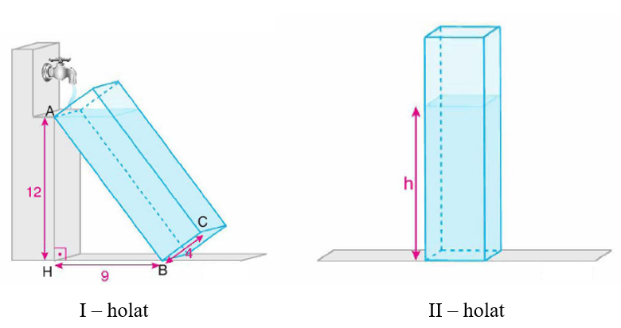

Ikkinchi holatdagi idishdagi suvning balandligini toping.

Yechish:

Javob: _________________________________

2. Asosining radiuslari bir xil bo‘lgan va balandliklari 8 cm bo‘lgan silindr va konus shaklidagi idishlar berilgan. I – holatda konus silindr ichiga asosi bilan joylashtirildi va silindrga 4 cm balandlikkacha suv quyildi (1-holat). II – holatda esa konus silindrga uchi bilan joylashtirildi va silindrga 4 cm balandlikkacha suv quyildi.

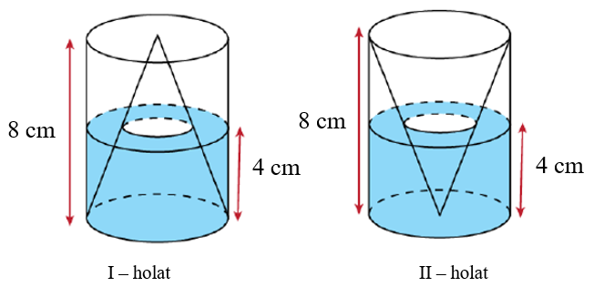

Birinchi holatda quyilgan suv hajmini ikkinchi holatda quyilgan suv hajmiga nisbatini toping.

Yechish:

Javob: _________________________________

3. Asosining radiuslari va balandliklari bir xil bo‘lgan silindr va konus berilgan. Konus suvga to‘ldirilib, silindr ichiga joylashtirildi (I - holat). So‘ngra konus yon yuzasining pastki qismiga yaqin joyga teshik ochildi. Natijada konusdan silindrga suv chiqib, silindr va konusdagi suv stahlari tenglashgan holatga keldi (II - holat).

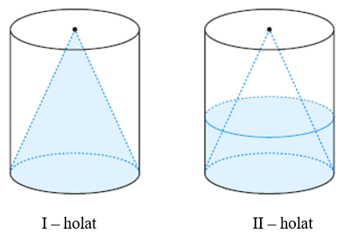

Agar konusda qolgan suv hajmi 19 cm3 bo‘lsa, silindrning hajmini toping.

Yechish:

Javob: _________________________________

4. Asosining radiusi 6 cm bo‘lgan konus shaklidagi idish va radiusi 3 cm bo‘lgan temir sharcha berilgan. Temir sharcha konus ichiga joylashtirildi (I - holat). So‘ngra konusga shar suvda qolgunicha ya’ni II – holatdagidek suv quyildi.

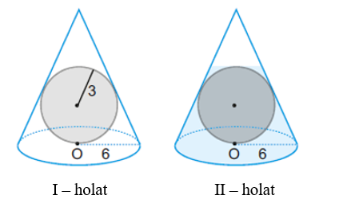

II – holatdagi konusdagi suv hajmini toping.

Yechish:

Javob: _________________________________

5. Yarim shar shaklidagi idishda 3 cm balandlikdagi suv bor (I -holat). Idish ikkinchi holatga keltirilganda, $BH$ kesma uzunligini toping.

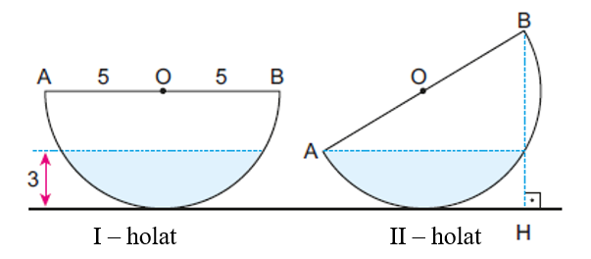

Yechish:

Javob: _________________________________

6. Asosining radiuslari bir xil bo‘lgan va balandliklari 8 cm bo‘lgan silindr va konus shaklidagi idishlar berilgan. I – holatda konus silindr ichiga asosi bilan joylashtirildi va silindrga 2 cm balandlikkacha suv quyildi (1-holat). II – holatda esa konus silindrga uchi bilan joylashtirildi va silindrga 4 cm balandlikkacha suv quyildi.

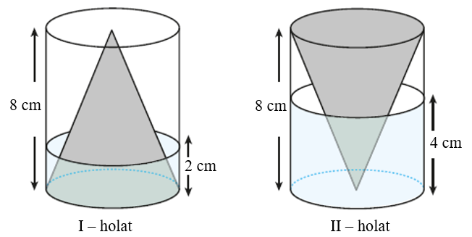

Birinchi holatda quyilgan suv hajmini ikkinchi holatda quyilgan suv hajmiga nisbatini toping.

Yechish:

Javob: _________________________________

7. Balandligi 6 cm bo‘lgan konus shaklidagi, balandligi 10 cm bo‘lgan silindr shaklidagi va balandligi 3 cm bo‘lgan kichik konus shaklidagi idishlar rasmda ko‘rsatilganidek joylashtirildi (I – holat). Katta konus suv bilan to‘ldirildi va II – holatga keltirildi ya’ni teskari aylantirildi.

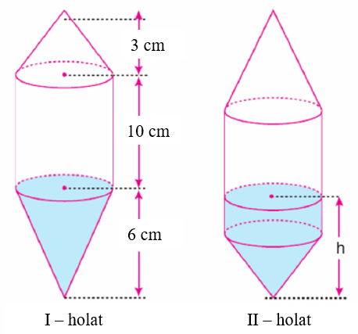

II holatdagi suvning balandligini toping.

Yechish:

Javob: _________________________________

8. Rasmda tasvirlangan konus shaklidagi idishni to‘ldirish uchun 27 stakan suv quyildi. Konusning balandligi 96 birlik. Agar jo‘mrak orqali konusdan 19 stakan suv olingan bo‘lsa, unda qolgan suvning balandligini toping.

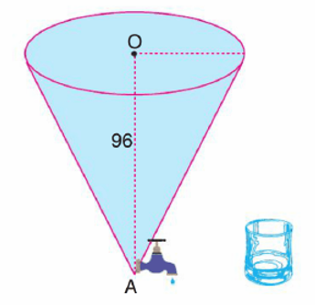

Yechish:

Javob: _________________________________

9. Asosining radiusi 2 cm, balandligi 10 cm bo‘lgan silindr shaklidagi idish suv bilan to‘ldirildi (I – holat). So‘ngra silindr idish ma’lum burchakka og‘dirildi va undagi suvning bir qismi to‘kildi. Silindr esa II – holat ko‘rinishiga keldi.

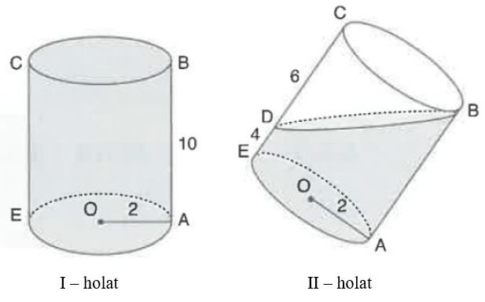

Birinchi holatdagi suv hajmini ikkinchi holatdagi suv hajmiga nisbatini toping.

Yechish:

Javob: _________________________________

10. Balandligi 10 cm bo‘lgan silindr shaklidagi idish ma’lum burchakka og‘gan holatda suv bilan to‘ldirildi (I – holat). So‘ngra silindr idish tik holatga keltirildi (II – holat).

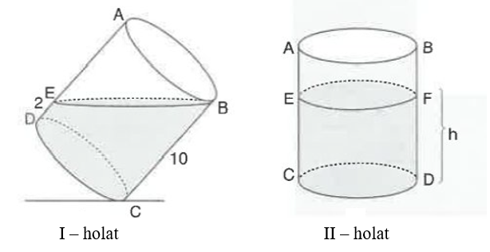

Ikkinchi holatdagi silindr ichidagi suvning balandligini toping.

Yechish:

Javob: _________________________________